The Downside of Generosity: How Rare Giving Fosters Stronger Social Connection
Minkwang Jang ª, Shereen J. Chaudhry ^{b}, & Ayelet Fishbach ^{b}
_{a} Singapore Management University, 50 Stamford Road, Singapore 178899, Singapore
_{b} The University of Chicago Booth School of Business, 5807 S. Woodlawn Avenue, Chicago, IL 60637, USA
Reference: Jang, M., Chaudhry, S. J., & Fishbach, A. (2026). The downside of generosity: How rare giving fosters stronger social connection. Organizational Behavior and Human Decision Processes, Article 104478. https://doi.org/10.1016/j.obhdp.2026.104478
Abstract
Giving serves not only to benefit others and society but also to foster social connections between givers and recipients. However, more giving is not necessarily merrier. This research finds that social connection depends not only on the act of giving but also on how many others receive the gesture from the same giver. Rare givers—those who give to fewer recipients—are perceived as more socially connected to each recipient than broad givers—those who give to many (the rare giving effect). This effect emerges across diverse contexts, including interpersonal gift exchanges in both new and existing relationships and corporate donations. As a result, rare givers enjoy a relational advantage: their gifts are valued more, and they are more likely to receive reciprocation (e.g., a gift in return or purchasing from the firm), even though they are perceived as less generous than broad givers. However, the negative effect of the number of recipients on perceived connection is attenuated when recipients are closely connected (e.g., donations to multiple charities supporting the same cause) or when gifts reinforce connections between recipients (e.g., friends sharing items in a matching set). These findings highlight an overlooked cost of broad generosity, with implications for managing interpersonal relationships and firms’ giving strategies.
Keywords: Generosity; Gift; Donations; Prosocial giving; Social connection; Relationships
1. Introduction
In Shakespeare’s Timon of Athens, Timon is an Athenian nobleman defined by his extreme generosity. He pays off his friends’ debts, provides substantial dowries for his servants, and hosts lavish banquets for a wide circle of guests. Timon famously declares himself to be “wealthy in my friends.” Yet when his fortune is exhausted, and he himself is in need, none of these supposed friends comes to his aid. Why was his generosity not reciprocated? Might Timon have been better off had he been less generous, helping only a few instead?
Acts of generosity are widely encouraged and socially valued. Generosity is celebrated as a moral virtue across cultures. People are taught to help and give to others: employees are encouraged to support their colleagues by going beyond formal duties (i.e., organizational citizenship behavior), and friends exchange gifts to express goodwill. Firms are also urged to give back to their communities. In return, givers often reap benefits such as enhanced reputation and social standing (Flynn, 2003; Hardy and Van Vugt, 2006; Ouyang et al., 2018), a positive self-image and greater well-being (Aknin et al., 2013; Gneezy et al., 2012; Williamson & Clark, 1989), as well as opportunities to build meaningful social connections with recipients (Ashworth et al., 2025; Cropanzano & Mitchell, 2005; Schwartz, 1967).
If giving is beneficial, then giving to more recipients might seem even more beneficial. From a social exchange perspective (Blau, 1964; Foa & Foa, 1980), the benefits that prosocial actors gain should be proportional to what they contribute within a given exchange. Under this view, the relationship within a giver–receiver dyad should not be influenced by the giver’s relationships or exchanges with other recipients. Thus, the benefits of giving would be expected to accumulate independently across recipients.
Timon’s story, however, suggests an alternative possibility: more acts of giving can be relationally self-defeating. When the number of recipients increases—that is, when giving becomes broader—giving may become less effective at fostering social connection with any single recipient, because the relational meaning conveyed by each act of giving is diluted. In that case, even when the material value is identical, an act of generosity may signal a stronger social connection when it occurs only a few times. This logic implies an ironic advantage to being a rare giver, i.e., someone who gives to relatively few recipients. Such givers not only conserve resources but may also enjoy greater relational benefits because each (rare) act of giving conveys a more concentrated signal of social connection.
In turn, gifts from rare givers may be valued more highly. While past work has examined the types of gifts that are valued more (Aknin & Human, 2015) and better signal connection (Chan & Mogilner, 2016; Goodman & Lim, 2018), whether other people also received gifts from the same giver represents an additional, and largely overlooked, factor. The same mug, baked good, or desk accessory may appear more valuable when received as a gift from a rare giver than from someone who gives gifts to many others. Further, while gift valuation partly depends on the rarity or uniqueness of the product itself (i.e., whether it is one of a kind; Lynn & Harris, 1997; Snyder & Fromkin, 1977), even non-scarce or non-unique gifts may be more cherished (rather than returned for store credit) and elicit reciprocity when they symbolize a stronger social connection with the giver due to the rarity of the giver’s giving behavior.
This research examines the effects of rare giving on perceived social connection and gift valuation. These effects highlight a fundamental trade-off between signaling relationship connection and cultivating a reputation for generosity. While broad giving may enhance perceptions of overall generosity, it can simultaneously undermine social connection with individual recipients. These dynamics suggest that simple tit-for-tat accounts of social exchange may be incomplete. Offering gifts to many coworkers or donating to multiple charities to win consumers’ favor may fall short of its expected benefits: gains in perceived generosity or reputation can be partially offset by diminished social connection with any single recipient.
1.1. Prosocial Behavior Signals Social Connection
Prosocial behavior encompasses voluntary actions intended to benefit others (Brief & Motowidlo, 1986; Eisenberg, 1991). These behaviors are typically discretionary rather than required or expected, which gives them social significance as signals of care, intention, or relational interest. At the individual level, prosocial acts include giving gifts to friends and family, donating money to charities, and volunteering time for community service. Within organizations, prosocial behavior often manifests as organizational citizenship behaviors (Podsakoff et al., 2000), such as helping colleagues, sharing information, and providing support beyond formal job duties. Beyond individuals, companies engage in prosocial behaviors such as corporate donations, cause-related marketing campaigns, sustainability programs, and community service initiatives.
Prosocial behavior can be understood as giving resources to others (Blau, 1964; Foa & Foa, 1980), fostering relational bonds, generating goodwill, and creating reciprocal obligations (Ashworth et al., 2025; Cropanzano & Mitchell, 2005; Schwartz, 1967). Individuals use gifts to maintain close relationships, while organizations use them to strengthen ties with employees, clients, customers, and communities. Gifts can also help initiate new connections: a new manager might bring snacks to a team, a company might donate to a local organization, or a neighbor might offer a welcome gift. An employee may spend time and effort helping a new colleague with a task, setting the stage for friendship and future mutual support. In these settings, acts of giving do more than transfer resources—they invite recipients and observers to infer what the act implies about the relationship. That is, they serve as relational signals. Indeed, signaling personal connection is a key motivation for giving: givers feel most rewarded when their gifts strengthen social bonds (Aknin et al., 2013). Charitable giving similarly conveys a bond with a cause (Lin-Healy & Small, 2012; Small & Simonsohn, 2008), with donors often favoring charities they feel personally connected to rather than those that maximize impact (Berman et al., 2018).
Because people lack direct access to others’ mental states, recipients and observers must rely on observable cues from giving episodes to infer this relational meaning (Kupor et al., 2017; Zhang & Epley, 2012). Some of these cues come from the gift itself. For instance, experiential gifts signal greater closeness than material gifts (Chan & Mogilner, 2016; Goodman & Lim, 2018), and givers often choose gifts that highlight their knowledge of the recipient, even at the expense of the recipient’s preferences (Ward & Broniarczyk, 2016). Other cues come from the context and pattern of giving. For example, people infer a stronger desire for connection from someone who donates smaller amounts repeatedly than from someone who donates the same total in a single lump sum, because frequent giving signals sustained attention (Schaumberg & Lin, 2025).
This research examines an additional contextual cue that extends beyond the focal dyadic exchange: a giver’s overall pattern of generosity across recipients. The number of recipients a giver supports—or the breadth of giving—may shape observers’ inferences about the strength of any particular relationship, even though this information lies outside the focal exchange.
1.2. The Breadth of Giving
Most people and organizations are, to some extent, “broad givers,” performing prosocial acts toward many others. People exchange gifts with many others and express support for various causes. During the holiday season, U.S. adults purchase gifts for multiple recipients, often more than six (YouGov, 2024). Individual donors in the U.S. also typically give to several charity organizations, averaging around three to five (Nonprofits Source, 2024). Within organizations, employees help multiple colleagues, and managers spread gifts of appreciation to team members. Companies also donate to multiple charities, sponsor various causes, and broadly distribute employee benefits.
These acts of giving are often public. Coworkers may share souvenirs in the office, while firms’ charitable acts are highlighted in the media. Generosity can also spread through word of mouth, as recipients share their appreciation with others. In today’s connected world, giving to multiple recipients is increasingly visible: birthday wishes, donations, and celebrations are shared online through social media and workplace platforms (e.g., Slack). Givers are often motivated to give publicly, as doing so can earn them recognition and social benefits (Small & Cryder, 2016; Yang & Hsee, 2022).
The visibility of giving suggests that recipients and observers may often discern not just whether someone gave, but also how many others they gave to. This raises the question of how the breadth of giving shapes its social consequences.
The often-discussed benefits of prosocial behavior center primarily on reputation and character inferences. Individuals and companies use charitable giving to reinforce their image as generous and socially responsible (Ariely et al., 2009; Ellingsen & Johannesson, 2011; Sen et al., 2016). Indeed, generous individuals are seen as warm and trustworthy (Bereczkei et al., 2007; Klein et al., 2015), and prosocial firms are viewed more favorably, garnering higher purchase intention among their consumers (Gershon & Cryder, 2018; Sen & Bhattacharya, 2001). Giving also enhances givers’ social capital, builds goodwill, and fosters a positive workplace climate (Chancellor et al., 2018; Flynn, 2003; Hardy and Van Vugt, 2006; Inesi et al., 2021).
Given these positive consequences of giving, broad giving seems unequivocally beneficial. However, it can carry mixed social implications because observers draw at least two types of inferences from prosocial acts. One concerns a giver’s general character and reputation—how generous or socially responsible they are. The other concerns the giver’s relationship with a particular recipient—whether the act reflects care or closeness within that dyad. The breadth of giving may strengthen the first inference while weakening the second: giving to many can make someone appear highly generous overall, yet make any single instance of giving seem less diagnostic of interest in or concern for the focal recipient. In the next section, we develop the theoretical case for why broad giving may sometimes signal a weaker social connection to a particular recipient, even as it enhances perceptions of the giver’s overall generosity.
1.3. Dilution of Social Connection
What giving signals about a particular relationship may depend on who else the giver gives to—that is, the giver’s broader social network. A social network is mentally represented as an associative network of interconnected agents (e.g., individuals, groups, or organizations), with ties that vary in perceived strength (Bernard et al., 1979; Brands, 2013). Importantly, relationships in a social network are not only defined by formal roles (e.g., employer-employee, family, friends), but also by interactions and resource transfers such as helping or giving (Borgatti et al., 2009). Thus, giving can create new connections or reinforce existing ties with recipients. Accordingly, within a social network, an agent may be connected to few or many others through acts of giving.
Because people mentally represent social networks in terms of who is connected to whom, their judgments often track the patterns of association within those networks (Basyouni & Parkinson, 2022). For example, individuals with many social ties—who therefore occupy central positions within a social network—are perceived as having higher status (Kilduff & Krackhardt, 2008; Venkataramani et al., 2010). Similarly, two individuals are more likely to be perceived as connected (e.g., predicted to be friends) when they share more overlapping ties, such as mutual friends (Sehl et al., 2023), or more distinctive common ties, such as rare preferences (Vélez et al., 2019).
How might the existence of other connections affect the perceived strength of a specific social tie? A well-established governing principle in associative network cognition is dilution: when a node is linked to many others, the strength of each individual association decreases. While originating from research on memory (Anderson, 1974; Anderson & Bower, 2014), the dilution principle has been extended to a broad range of judgments: for instance, when one product serves many functions, it is seen as less effective for any single function (e.g., people prefer a regular pen over a multifunctional pen with a laser pointer for writing; Zhang et al., 2007). The additional purposes “dilute” the perceived effectiveness of the product for any specific purpose. Likewise, agents with more expansive social networks, whether organizations or individuals, may be perceived as having weaker ties with their individual connections.
The perception of weaker ties as the number of connections grows can also arise from principles of causal attribution. When a single cause produces multiple effects, each individual causal link is perceived as weaker, as if a cause’s influence is spread across outcomes (Stephan et al., 2023; Sussman & Oppenheimer, 2020). This logic echoes Kelley’s (1973) covariation account: a behavior is more likely to be attributed to a target-specific motive when it is distinctive—directed toward one target rather than many. For instance, an award given selectively to one recipient (i.e., high on distinctiveness) conveys more about that person’s merit than when the same award is given broadly.
Applied to giving, this attribution logic implies that observers may perceive prosocial acts performed for many different recipients as less relationship-specific. When someone helps or gives to only one colleague, the act more readily supports an inference of special regard for that colleague. But when the same person routinely helps many colleagues, the act is more easily attributed to a general prosocial disposition than to a unique relationship with any particular recipient.
This helps to explain how broad giving can produce mixed social consequences. While it can strengthen impressions of the giver’s general generosity, it simultaneously weakens what any single act of giving signals about a particular tie, because a behavior performed broadly toward many targets is less readily interpreted as evidence of concern for a specific target.
1.4. The Rare Giving Effect
From a social exchange perspective (Blau, 1964), each act of giving establishes a reciprocal relationship proportional to the value transferred. Giving to one recipient should not affect relational outcomes with others, which implies that benefits are assumed to accumulate independently across giver-recipient dyads. Under this logic, an employee who brings coffee to five colleagues accumulates five times the relational benefit of bringing coffee to one, and a company that donates to ten charities should build ten times the goodwill of donating to a single cause.
In contrast, we propose that the strength of the social connection signaled by giving depends in part on transactions that occur outside the focal dyad. Holding the tangible value being endowed constant, rare givers will be perceived as having stronger social connections with their recipients, compared to broad givers. Formally stated:
H1: The social connection between a giver and an individual recipient is perceived as stronger when there are fewer recipients (the rare giving effect).
Because relationship closeness tends to be mutual (Davis and Rusbult, 2001), recipients’ own feelings of connectedness should mirror the strength of connection they infer on the part of the giver. Accordingly, recipients will also feel closer to rare givers, whom they assume feel closer to them.
This prediction implies a trade-off between signaling generosity and fostering social connection. Broad givers, who give to many recipients, contribute more overall and are therefore likely to be perceived as more generous, potentially enhancing their general reputation. Yet, broad giving dilutes the perceived social connection with any single recipient. As a result, broad givers may fail to build as strong, meaningful ties to individual recipients as rare givers. In other words, maximizing their reputation as generous undermines perceived social connection.
The rare giving effect should have downstream consequences for how recipients subjectively value gifts. A gift’s subjective value is only partly determined by its market price or cost (Flynn & Adams, 2009). In fact, recipients’ own willingness to pay for gifts they receive is often 33% or more below the price paid by the givers (Waldfogel, 1993, 2009). While some gifts carry no market value (e.g., cards or homemade items), gifts can hold substantial personal significance by reminding recipients of special experiences (Chu & Shu, 2023; Wilkins, 2011) or social bonds (Belk, 1976; Camerer, 1988; Chan & Mogilner, 2016; Givi et al., 2022). At times, objective value may even be negatively correlated with subjective value. On Valentine’s Day, a dozen roses might be valued more highly than a vacuum cleaner, despite costing less. For gifts with no market value (e.g., a card), the entire value may be symbolic. Thus, we predict that rare giving will increase the subjective value of the gift because the gift conveys a stronger social connection. Formally stated:
H2: Recipients assign a higher subjective value to a gift when there are fewer recipients.
H3a: Perceived social connection (H1) mediates the effect of the number of recipients on subjective valuation of the gift (H2).
Importantly, we distinguish rare givers from rare gifts or rare wins. Product value often increases with market rarity (Cialdini, 1987; Lynn, 1991): limited-edition items are prized because they are scarce, and artworks are frequently sold as numbered prints to preserve their value. Likewise, recipients may value their luck rather than a social relationship. For example, a lottery winner may highly value the prize without feeling any relational closeness to the prize giver.
However, we propose that the stronger connection perceived from rare giving is not simply due to the statistical rarity of receiving a gift or being part of a smaller group. Receiving a gift as one of the few recipients by chance or due to external constraints should not automatically lead to feeling more connected to the giver. Rather, what matters is whether recipients perceive that the giver intentionally selected them. When giving is intentional, the number of recipients becomes a meaningful signal of relational interest. In contrast, when recipient selection is perceived as unintentional, the number of recipients provides little insight into the giver’s intentions and thus should have minimal impact on perceived social connection. Accordingly, we predict that perceived social connection will mediate the effect of the number of recipients on subjective gift value only when recipients believe the giver deliberately chose them. Intentionality, therefore, serves as a key moderator of the mediation specified in H3a. Formally stated:
H3b: The mediating effect of perceived social connection (H3a) occurs only when the giver intentionally selects the recipients (i.e., moderated mediation).
What determines the degree to which social connection is diluted by giving to more recipients? We suggest that this depends on the extent to which the recipients are socially connected to one another. This prediction follows from the logic of associative networks: for example, in goal systems, when multiple means are closely related, their joint presence is less likely to dilute their perceived connection to a focal goal (Kruglanski et al., 2018). A pen used for both writing and drawing does not appear less effective for writing because drawing is a closely related function. In contrast, when the same pen also functions as a laser pointer—a function not closely related to writing—its perceived effectiveness for writing is reduced (Zhang et al., 2007). In addition, when multiple recipients are linked through shared group membership, a common cause, or existing relational ties, they are more likely to be perceived as part of a coherent social unit (Igarashi & Kashima, 2011; Lickel et al., 2000).
Thus, when potential recipients are more closely connected or form a more cohesive group, giving to one can be interpreted as extending beyond that individual to related others. Consequently, giving to multiple, related recipients (e.g., charity organizations that support the same social cause) is less detrimental to the perception of a strong connection with any single recipient. In some cases, the gift itself can reinforce the connections among recipients. For example, when individual gifts combine to form a meaningful set (e.g., tiles that together create a mosaic), they highlight the recipients’ interdependence and can enhance perceptions of group coherence. As a result, stronger social connections among the recipients should attenuate the dilution of the social connection between the giver and each recipient. Formally stated:
H4: The negative effect of increasing the number of recipients on perceived connection (H1) diminishes when recipients are more socially connected (i.e., moderation).
Finally, we consider the consequences for reciprocation. From a social exchange perspective, giving is not merely a one-time prosocial act. Rather, it assumes that recipients will feel an obligation to return benefits they have received (Blau, 1964; Cropanzano & Mitchell, 2005). For example, companies often expect consumers to reciprocate charitable donations directed toward their communities through increased loyalty. Similarly, in employer-employee relationships, workers reciprocate gifts or bonuses from employers by exerting greater effort (Kube et al., 2012), and within teams, employees who receive help from colleagues are more likely to engage in organizational citizenship behaviors themselves (Deckop et al., 2003). Thus, givers accumulate social capital, which can be drawn upon in future exchanges (Adler & Kwon, 2002). Further, by reciprocating, recipients not only return the tangible benefits but also provide assurance that they acknowledge the givers’ relationship interests and are open to future engagement.
However, as the story of Timon of Athens reminds us, even extraordinary generosity may fail to elicit reciprocation. We propose that whether giving prompts reciprocation depends on the strength of the social connection recipients perceive. Even when gifts are identical in amount or value, rare givers are more likely to receive reciprocation—whether as a return gift, or in the case of corporate giving, increased purchases—because the social connection signaled by their giving is less diluted. Formally stated:
H5: Recipients are more likely to reciprocate to the giver when there are fewer recipients.
1.5. The Present Research
We next report nine studies (N = 2750; summarized in Table 1) designed to test our hypotheses in both individual and organizational giving contexts. We specifically focused on material and voluntary giving because these forms of prosocial behavior involve deliberate resource transfer, making them well-suited to examine how giving signals social connection. Across studies, perceived connection was measured as inferences—by recipients or observers—about the giver’s felt connection with the recipient and as recipients’ own sense of connection with the giver.
Table 1. Summary of Studies and Key Findings.
Study | Main Outcome Variable | Main Finding | Hypotheses Tested
Study 1 | Perceived connection | Recipients felt more strongly connected to the giver when they were the sole recipient than when they were one of three recipients. | H1
Studies 2a-b | Gift valuation | 2a. Gift valuation: Participants valued a gift from friends and acquaintances more (and perceived a stronger connection) when they were one of a few (vs. many) recipients. — 2b. Gift choice: Participants were more likely to keep the cheaper gift from the rare giver (i.e., regifted the expensive one from the broad giver). | H2, H3a
Studies 3a-b | Gift valuation | 3a. Robustness to varied gifts: Participants valued a gift less when there were multiple recipients, regardless of whether the gifts were identical or varied across recipients. — 3b. Moderated mediation by intentionality: Perceived social connection mediated the effect of the number of recipients on subjective value only when recipients were intentionally chosen. | H2; H3a, H3b
Studies 4a-b | Perceived connection (Moderation) | 4a. Moderation by relatedness of the recipients: Participants perceived a brand donating to multiple (vs. single) charities as less connected to the focal charity. This effect was attenuated when the charities supported related (vs. unrelated) social causes. — 4b. Moderation by gifts that connect the recipients: Participants perceived a weaker connection when a friend gave gifts to many others (vs. only a few) and valued the gift less. This effect was attenuated when the gifts formed a set that strengthened connections among recipients. | H4
Studies 5a-b | Reciprocation | 5a. Giving a gift in return: Participants were more likely to reciprocate to a rare giver than to a broad giver. — 5b. Purchase intention: Preference for the rarely-giving (vs. broadly-giving) firm increased when participants were beneficiaries of the firms’ giving (i.e., when purchase would be partly motivated by reciprocity). | H5

All studies (final sample size, participant exclusions, and analyses) were pre-registered. The target sample sizes were determined to achieve at least 80% power for a medium effect size (Cohen’s d = 0.5). We report supplementary results (sensitivity analyses for all studies and any additional exploratory measures and analyses), sample stimuli, and supplementary studies in the Supplementary Materials. We adhered to the APA Style Journal Article Reporting Standards for quantitative studies (https://apastyle.apa.org/jars). We used R to analyze the data for all studies. All data, study materials, code for analyses, and pre-registrations are available in the OSF repository: https://osf.io/38dx6.
2. Study 1: Giving to Fewer Signals Stronger Social Connection
In Study 1 (pre-registration: https://aspredicted.org/9k3s-fpfc.pdf), we tested whether a gift signals a weaker connection when the recipient is aware that others also received a gift (H1). Passersby on a university campus received a gift from an anonymous participant, similarly to how past research tested the effect of gift-giving in the field (e.g., Kumar and Epley 2018; Wilson et al. 2005). While even gifts from strangers can foster social connection by signaling initial interest in a relationship, we predicted that their effectiveness depends on whether recipients learned that the giver had given only to them or also to multiple others.
2.1. Method
2.1.1. Participants
We recruited adult participants from on-campus locations at a university in the U.S. While this study involved recruiting both gift-givers and gift-recipients, our pre-registered hypotheses concerned only the data from the recipients. Overall, we recruited 143 givers (109 in the single-recipient condition and 34 in the multiple-recipients condition) and 211 recipients. One recipient declined to answer our questions. As pre-registered, we excluded two participants who did not answer some of the questions and two additional participants who failed our manipulation check (described below). While not pre-registered, we additionally excluded five participants who previously participated in the study (whether as givers or recipients; including these responses does not change our conclusions, see additional analyses in Supplementary Materials B). Our final sample contained 201 valid responses from gift-recipients (no demographic data collected).
2.1.2. Procedure
Research assistants (RAs) approached potential participants in open areas on campus. The givers were asked to choose strangers in the same space to give chocolates to (detailed procedures, RA scripts, and study materials are available on OSF). In the single-recipient condition, the givers chose one recipient. In the multiple-recipients condition, they chose three separate recipients who were not sitting or standing together. This design required three times as many givers in the single-recipient condition as in the multiple-recipients condition in order to collect a similar number of recipients in each condition. To balance the participants across the conditions in each study session, the RAs alternated between recruiting three givers in the single-recipient condition and recruiting one giver in the multiple-recipients condition. The givers signed their initials on cards that were to be given to the recipients along with the chocolates (see Supplementary Materials A). As an exploratory question, we elicited givers’ predictions on whether the gift would make the recipient feel connected to them (1: definitely no, 7: definitely yes; results available in Supplementary Materials B).
Next, the RAs approached the recipients designated by the giver individually. The recipients were informed that an anonymous giver chose to give them chocolate, saying: “The other participant in this study could choose either one person or three people to give a chocolate to. This person [just chose you (single-recipient condition) / chose three people, and you are one of those three people (multiple-recipients condition)]. Here’s the chocolate, and also a card from that person.”
After receiving the card and the chocolate, the recipients completed a survey that had them rate perceived connection (“Having received this chocolate from this person, do you feel connected to this person?”) and their interest in meeting the giver as a potential additional measure of perceived connection (“Would you be interested in meeting this person at a future point?”, 1: definitely no, 7: definitely yes for both questions). Recipients also completed a manipulation check (“Were you the only one to receive the chocolate from this giver, or were there others, as far as you know?”).
2.1.3. Results
The internal consistency between perceived connection and interest in meeting the giver was low (Cronbach’s α = .55), and hence, as pre-registered, we limited our analysis to the first measure. In support of our hypothesis (H1), participants in the multiple-recipients condition felt less connected to the giver than those in the single-recipient condition (M_{Multiple} = 3.60, SD = 1.55 vs. M_{Single} = 4.05, SD = 1.45), Welch’s t-test, t(196.33) = −2.10, p = .037, Cohen’s d = 0.30. The interest in meeting the giver was not significantly different across the conditions (M_{Multiple} = 4.98, SD = 1.56 vs. M_{Single} = 5.11, SD = 1.57), Welch’s t-test, t(198.57) = −0.58, p = .56, possibly reflecting general curiosity about the identity of the mystery giver in this particular experimental setting.
2.1.4. Discussion
Rare giving increased perceived social connection: participants felt less connected to the giver when the giver gave out more gifts. These findings highlight an irony: rare giving, even when low-cost and potentially reflecting overall ungenerous behavior, can nevertheless signal a stronger social connection.
3. Studies 2a-b: A Gift from a Rare Giver Is Valued More
We examined whether rare (vs. broad) giving increases the subjective value of a gift (H2). In Study 2a (pre-registration: https://aspredicted.org/y9t5-gs4x.pdf), participants evaluated a gift from an existing non-romantic friend or acquaintance who gave gifts to only a few (a rare giver) or to many people (a broad giver). We predicted that gifts from rare givers would be valued more across relationships (i.e., for both friend and acquaintance). In Study 2b (pre-registration: https://aspredicted.org/3z48-6nrk.pdf), we measured subjective value using a consequential, incentive-compatible decision: choosing between keeping a cheaper gift from a rare giver (who gave only to the participant) or a more costly gift from a broad giver (who gave to multiple recipients). We predicted that, without knowing who else received the gift, participants would prefer the more expensive gift. However, knowing the expensive gift was received from a broad giver would shift preferences toward keeping the cheaper gift, valued more because it comes from a rare giver.
3.1. Study 2a: Gifts from Friends and Acquaintances
3.1.1. Method
Participants. We opened the study to 479 participants from Prolific, aiming for a target sample size of 400. Prolific returned 469 complete responses from unique IP addresses. After excluding 59 participants for failing attention checks and 10 additional participants for indicating that they did not want to maintain (or strengthen) the real-life relationship they reported (as pre-registered), we analyzed 400 valid responses (M_{Age} = 43.21, SD = 13.10; 53% women, 5 indicated ‘other’).
Procedure. Participants were randomly assigned to one of 2 (number of recipients: few vs. many) × 2 (relationship: friend vs. acquaintance) between-participants conditions.
Participants provided the initials of either a “non-romantic friend” or an “acquaintance” (someone they “know personally but is not family or a close friend, such as a colleague, classmate, neighbor, teammate, or a member of a social or community group”) based on their assigned relationship condition and described their relationship with that person. For exploratory purposes, participants rated the relationship on valence (e.g., positive or negative), importance, and time spent together (all on a 9-point scale; Supplementary Materials B).
Next, participants read a scenario where the named person returned from a trip to Paris and brought souvenirs. In the few-recipients condition, they read, “They picked up just a couple of souvenirs (like the ones in the picture below). They didn’t want to buy gifts for everyone, but planned to give them to just a couple of people. You are one of a couple of people to receive a souvenir from [initials], while most others did not.” In the many-recipients condition, they read, “They bought a suitcase full of souvenirs (like the ones in the picture below). They wanted to give them to as many people as possible. Along with many others, you receive a souvenir from [initials].” A picture of several Paris-themed keychains was displayed below (same image in both conditions; stimuli available on OSF).
We measured subjective value (two questions: “How personally valuable would this gift from [initials] feel to you?”, 1: not at all, 9: very valuable; “How meaningful would this gift feel to you?”, 1: not at all, 9: very meaningful) and perceived connection (three questions: “How much does this gift suggest that [initials] feels connected to you?”, 1: not at all, 9: very much; “How strongly would you feel connected to [initials] after the situation in the scenario?”, 1: no more, 9: a lot more than before receiving the gift; “How would this gift make you feel toward [initials]?”, −4: much more distant, 4: much closer).
We also measured perceived generosity as an exploratory variable (“How generous would [initials] appear toward others in general based on their giving behavior in the scenario?”, “Based on their giving behavior in the scenario, how inclined would [initials] appear to share or give to others in everyday life?”, 1: not at all, 9: a lot for both questions). Participants completed an attention check confirming the number of recipients in the scenario (few, many, or do not recall) and indicated whether the person they named for the study was someone they wished to stay close with or become closer to.
3.1.2. Results
We averaged the three measures of perceived connection (Cronbach’s α = .86; Fig. 1, left). We regressed perceived connection on contrast-coded variables for the number of recipients (−1: many, 1: few), relationship (−1: acquaintance, 1: friend), and the interaction between the two terms.
Consistent with our earlier results and main hypothesis (H1), we found a significant main effect of the number of recipients on perceived connection, B = 0.57, SE = 0.078, t(396) = 7.32, p < .001: Participants reported a stronger connection when the giver (assumed to be their real friend or acquaintance) gave to fewer people. There was also a significant main effect of relationship, B = 0.19, SE = 0.078, t(396) = 2.46, p = .014, but the interaction was not significant, B = −0.081, SE = 0.078, t(396) = −1.04, p = .30. Exploratory simple effect analyses found that the effect of the number of recipients (recoded as 0: many, 1: few) was significant for both friends, B = 0.97, SE = 0.22, t(396) = 4.47, p < .001, and acquaintances, B = 1.30, SE = 0.22, t(396) = 5.87, p < .001.
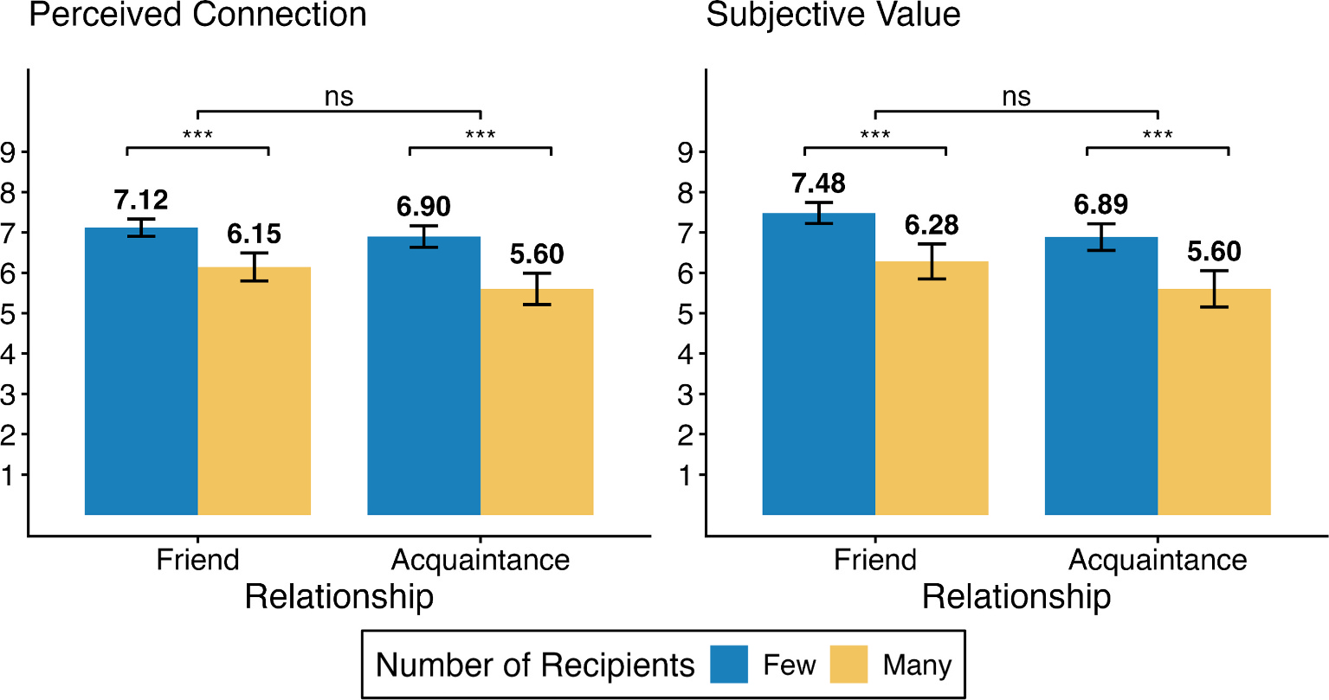
Fig. 1. Perceived Connection and Subjective Value in Study 2a. Note. Error bars display 95% confidence intervals. ns: p > .05, ***: p < .001.
We found a similar pattern for subjective value (two measures averaged; Cronbach’s α = .95; Fig. 1, right): a significant main effect of the number of recipients, B = 0.62, SE = 0.094, t(396) = 6.61, p < .001, consistent with our prediction that the subjective value of a gift is higher when there are fewer recipients (H2). While there was a significant main effect of relationship, B = 0.32, SE = 0.094, t(396) = 3.40, p < .001, the interaction was not significant, B = −0.021, SE = 0.094, t(396) = −0.22, p = .83. Exploratory simple effect analyses (as above) revealed significant effects of the number of recipients on subjective value for both friends, B = 1.20, SE = 0.26, t(396) = 4.55, p < .001, and acquaintances, B = 1.28, SE = 0.27, t(396) = 4.80, p < .001.
Consistent with our theory, perceived connection significantly mediated the effect of the number of recipients on subjective value (H3a), with a significant indirect path: few (vs. many) recipients → perceived connection → subjective value, a × b = 1.07, 95% CI = [0.78, 1.37] (using R “mediation” package with 5,000 bootstrapped samples, controlling for the relationship conditions). After accounting for this path, the direct effect was not significant: c′ = 0.17, 95% CI = [−0.074, 0.42].
The number of recipients influenced perceived giver generosity in the opposite direction of perceived connection and subjective value. An analysis of generosity ratings (Cronbach’s α = .75) using the same regression model revealed a significant negative main effect of the number of recipients, B = −0.34, SE = 0.076, t(396) = −4.43, p < .001. Broad givers were thus perceived as more generous, even though they were seen as less connected and their gifts as less valuable. Neither the main effect of relationship nor the interaction with the number of recipients was significant (ps > .05; Supplementary Materials B).
3.2. Study 2b: Preferring a Cheaper Gift
3.2.1. Method
Participants. We opened the study to 265 participants from MTurk, aiming for a target sample size of 250. MTurk returned 251 complete responses from unique IP addresses. Everyone passed our additional attention check at the end of the survey, so we analyzed data from all 251 participants (M_{Age} = 38.55, SD = 10.91; 43% women, 2 indicated ‘other’).
Procedure. Participants were randomly assigned to one of two (information on the number of recipients from the givers: present vs. absent) between-participants conditions.
Participants were told they were part of a five-person group with two givers and three receivers and that they were assigned the role of a receiver. They read that each of the two senders would decide whether to send a gift to each of the three receivers. In reality, the experiment included only receivers, and they were not in groups with other actual participants.
After the initial instructions, to ensure that participants felt that they were sharing enough information with the senders to allow for forming an interpersonal connection, they answered a question from the Fast Friends Procedure (“Is there something you’ve dreamed of doing for a long time? Why haven’t you done it?”; Aron et al., 1997). This question was designed to reveal something personal about themselves to the senders and promote interpersonal closeness. Their answers were supposedly shared with the senders.
Participants were then presented with pre-programmed responses that displayed the decisions by the two senders. Our key manipulation was whether participants received information about the number of receivers each sender sent gifts to (Table 2). In the information-absent condition, participants read that they received two gifts, one from each sender: a digital clock with a current price of $16.99 and another clock with a current price of $17.99 (we presented two digital clock products available online and used the products’ actual images and prices on the day that the survey was first launched; it was not specified whether givers were required to pay for gifts or simply chose them). Participants in this condition evaluated gifts only based on the price and product features, which allowed us to assess baseline preference.
Table 2. Design and Stimuli in Study 2b.
 | Lower-Priced Gift | Higher-Priced Gift
Message — Info-Absent condition | KJ sent a gift to you. | RM sent a gift to you.
Message — Info-Present condition | KJ sent a gift only to you. Other receivers did not receive a gift from KJ. | RM sent a gift to receivers MO, NR, and you.
Description of the gift (common to both conditions) | Digital Alarm Clock, 6.5 Inch Large Display LED Mirror Electronic Clock — Current Price: $16.99 | Digital Alarm Clock, 7 Inch Large Display LED Mirror Electronic Clock — Current Price: $17.99

In the information-present condition, information about each gift was accompanied by the number of receivers each sender chose to give to. Specifically, the sender of the lower-priced gift sent a gift only to the participant and not to the other two receivers, while the sender of the higher-priced gift sent gifts to all three receivers.
Next, participants read that, because they had received gifts from two people, they needed to choose one to regift to another (unspecified) participant. Participants indicated which of the two gifts they would regift, thereby keeping the other gift. To make this choice incentive-compatible while keeping costs manageable, we implemented a lottery: Participants read that one out of 100 participants would be randomly selected to have their choice of gift implemented—that is, in effect, one out of 100 receivers would actually receive the gift they selected.
As secondary measures, participants also rated the relative subjective value of the higher-priced gift, compared to the lower-priced gift (“Which person’s gift feels more personally valuable?” and “Which person’s gift feels more meaningful to you?”, 1: lower-priced gift, 7: higher-priced gift for both questions), and the relative perceived connection with the givers (“Which sender do you feel more strongly connected to?”, 1: lower-priced gift-giver, 7: higher-priced gift-giver).
We also similarly measured the perceived generosity of the senders (“Which sender do you think is more generous?”) and liking of the senders (“Which sender do you like more after receiving gifts from them?”, 1: lower-priced gift-giver, 7: higher-priced gift-giver for both questions). In the survey, the endpoints of the scales used in these questions were labeled appropriately to the question (e.g., for the question about personal value, 1: “The gift from KJ is more personally valuable”, 7: “The gift from RM is more personally valuable”; full survey materials including the exact wordings of the scales are available on OSF).
3.2.2. Results
As expected, in the information-absent condition, where participants received only product information and no information about other recipients, only 34% (44/128) preferred the lower-priced gift, with the majority choosing the higher-priced option. By contrast, significantly more participants in the information-present condition chose to keep the lower-priced gift (69%, 85/123), χ²(1) = 28.91, p < .001, Cohen’s h = 0.71. That is, participants’ preference for the higher-priced gift was reduced when they learned that its sender gave to more recipients. Thus, a significant proportion of participants were willing to give up a gift with a higher monetary value when they were the sole recipients of the cheaper gift. This result confirms our hypothesis (H2) that people value a gift more when they are one of the few (vs. many) to receive it from a particular giver. In this case, the added value of rare giving reversed the baseline preference, shifting it from the costlier gift to the cheaper one.
Turning to our additional measures, we found a similar effect using the subjective value scale (averaging personal value and meaningfulness, Cronbach’s α = .90): The relative subjective value of the higher-priced (vs. lower-priced) gift was lower in the information-present condition (M = 2.79, SD = 1.74) than in the information-absent condition (M = 4.42, SD = 1.00), t(192.9) = −9.03, p < .001, Cohen’s d = 1.15. This suggests that knowing the number of recipients per sender reduced participants’ subjective value of the higher-priced gift, relative to the lower-priced gift. Put another way, knowing the number of recipients increased participants’ relative valuation of the lower-priced gift.
Consistent with our earlier results, the relative perceived connection to the higher-priced gift-giver (measured on a single scale in comparison to the lower-priced gift-giver) was lower in the information-present condition (M = 2.58, SD = 1.62) than in the information-absent condition (M = 4.43, SD = 1.02), t(203.86) = −10.80, p < .001, Cohen’s d = 1.38. Thus, knowing how many receivers each sender gave gifts to reduced participants’ relative feeling of connection to the higher-priced gift-giver. To examine whether the lower perceived connection underlies the negative effect of the larger number of recipients on the subjective value of the gift, we conducted an exploratory mediational analysis (using R “mediation” package with 5,000 bootstrapped samples): The indirect path (information present (vs. absent) → perceived connection → subjective value) was significant for both measures of subjective value: the binary choice outcome (i.e., fewer participants keeping the higher-priced gift, a × b = −0.26, 95% CI = [−0.34, −0.17]) and the composite scale measure (i.e., lower valuation of the higher-priced gift, a × b = −1.36, 95% CI = [−1.68, −1.07]), confirming that perceived connection significantly mediated the effect on subjective value.
Participants rated the higher-priced (vs. lower-priced) gift-giver as more generous in both the information-absent (M = 4.78, SD = 1.09), compared to the midpoint 4, t(127) = 8.08, p < .001, and information-present condition (M = 5.12, SD = 1.70), t(122) = 7.31, p < .001, and in fact, directionally more so (though non-significantly) in the information-present condition than in the information-absent condition, t(206.78) = 1.88, p = .062. Therefore, although learning that the higher-priced gift-giver also gave to others did not reduce how generous they were perceived to be, it did reduce how connected recipients felt to that giver and how much they valued the gift. Additionally, liking of the sender followed perceived connection, with participants reporting a weaker liking of the higher-priced (vs. lower-priced) gift-giver in the information-present condition (M = 2.93, SD = 1.74) than in the information-absent condition (M = 4.55, SD = 1.06), t(199.93) = −8.89, p < .001. That is, knowing how many receivers each sender gave gifts to also reduced the relative liking of the higher-priced gift-giver.
3.3. Discussion
Regardless of whether participants were considering a gift from a friend or an acquaintance, they inferred a stronger connection and valued the gift more when there were fewer recipients (Study 2a). Thus, the rare giving effect appears for both close and distant relationships. Further, despite preferring a more expensive gift at baseline, participants flipped their preferences when they had information about rare giving: They were willing to forgo an expensive gift in favor of a cheaper one when the sender of the cheaper gift had fewer recipients (Study 2b). Although more generous givers give to more people, their gifts are nonetheless valued less than those from someone who gives more sparingly.
4. Studies 3a-b: Perceived Connection Underlies Gift Valuation
Studies 3a-b examined the subjective value of gifts and whether perceived connection underlies this effect, while addressing several alternative explanations. Drawing on the minimal group paradigm (Billig & Tajfel, 1973; Tajfel, 1970), we developed a minimal giving paradigm in which participants exchanged symbolic gifts (e.g., virtual flowers). Although these flowers had no material value, we expected them to carry subjective value that would diminish as the number of recipients increased.
In earlier studies, the gifts of broad givers may have seemed less valuable because identical gifts were repeated across recipients. In Study 3a (pre-registration: https://aspredicted.org/4443-4qy3.pdf), we varied whether givers distributed the same flowers or distinct, varied flowers. We also explicitly stated the total number of flowers each giver had, ensuring that the perceptions of total resources were held constant.
Another alternative explanation is that gifts from rare givers may have fostered a stronger connection and seemed more valuable simply because they were scarce in the market (Cialdini, 1987; Lynn, 1991), with only a “lucky few” receiving them (Wang et al., 2021), or because of the statistical rarity of receiving a gift. In contrast, we theorized that the rare giving effect reflects the rare giver’s gift signaling stronger relational interest. To test this, Study 3b (pre-registration: https://aspredicted.org/nxv4-97gz.pdf) manipulated intentionality: recipients were either randomly assigned or deliberately chosen by the giver. We predicted a moderated mediation such that rare giving leads to a stronger perceived connection and, in turn, mediates the effect on subjective value (H3a) only when recipients are intentionally selected (H3b).
4.1. Study 3a: Distinguishing Rare Givers from Distinct Gifts
4.1.1. Method
Participants. We opened the study to 153 U.S. participants from Prolific, aiming for a target sample size of 150. We received 152 complete responses from unique IP addresses, and after excluding two responses from those who failed our attention checks (as pre-registered), we analyzed 150 valid responses (M_{Age} = 37.03, SD = 13.00; 53% women, 1 indicated ‘other’).
Procedure. Study 3a employed a 2 (number of recipients: one vs. five) × 2 (gift variety: same vs. varied) within-participants design. As in Study 2b, participants were ostensibly assigned to play the receiver in a game with other participants, this time, involving five receivers (including the participant) and four senders. In reality, all participants were receivers.
Each participant first answered a brief question designed to prompt personal self-disclosure (“What is your favorite movie? What do you think it says about yourself?”). Participants were informed that the senders would read their answers to this question, as well as answers from other receivers, to decide whether to send each receiver a virtual flower (displayed by a flower icon).
Participants viewed the decisions by each of the four senders one at a time, each representing one of the four within-participants conditions, in randomized order (Fig. 2). Specifically, in the same-gifts condition, the senders had five identical virtual flowers to give, while in the varied-gifts condition, all five flowers were different. In the one-recipient condition, only the participant received a flower, while in the five-recipients condition, all receivers received a flower (either the same or different flowers, depending on the gift-variety condition). Across the four conditions (senders), the flower that the participant received remained the same.
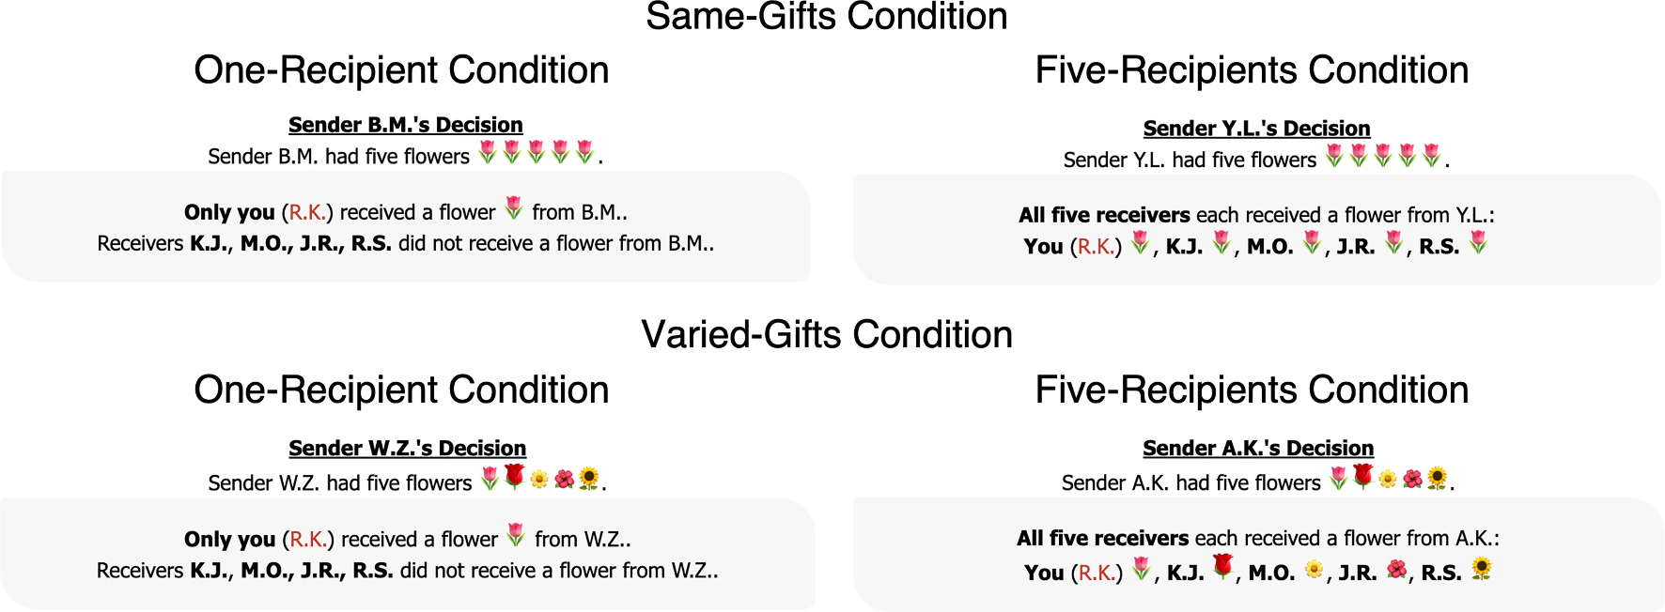
Fig. 2. Design and Stimuli in Study 3a.
For each sender, participants rated the subjective value of the gift (“How personally valuable does the flower you received from [sender name] feel?”, 1: not at all, 9: very valuable; “How meaningful does this flower feel?”, 1: not at all, 9: very meaningful) and perceived connection (“How strong do you think the connection between you and this sender is?”, −4: very weak, 4: very strong; “How close do you feel with this sender?”, −4: very distant, 4: very close; “How much do you agree with the following statement? There is a connection between me and this sender.”, −4: completely disagree, 4: completely agree). As a secondary measure, participants rated the perceived generosity of the giver (“How generous do you think this sender is?”, 1: not generous at all, 9: very generous).
4.1.2. Results
We first examined perceived connection (three measures averaged; average Cronbach’s α = .96; Fig. 3, left). When the flowers were the same (i.e., within the same-gifts condition), participants felt more connected to the giver when they were the only recipient (vs. one of five) of the flower (M_{One} = 1.15, SD = 2.15 vs. M_{Five} = −0.70, SD = 2.00), paired t-test, t(149) = 11.68, p < .001, Cohen’s d = 0.95. The results were consistent with varied flowers (i.e., within the varied-gifts condition, M_{One} = 1.16, SD = 2.12 vs. M_{Five} = −0.80, SD = 2.00), paired t-test, t(149) = 12.52, p < .001, Cohen’s d = 1.02.
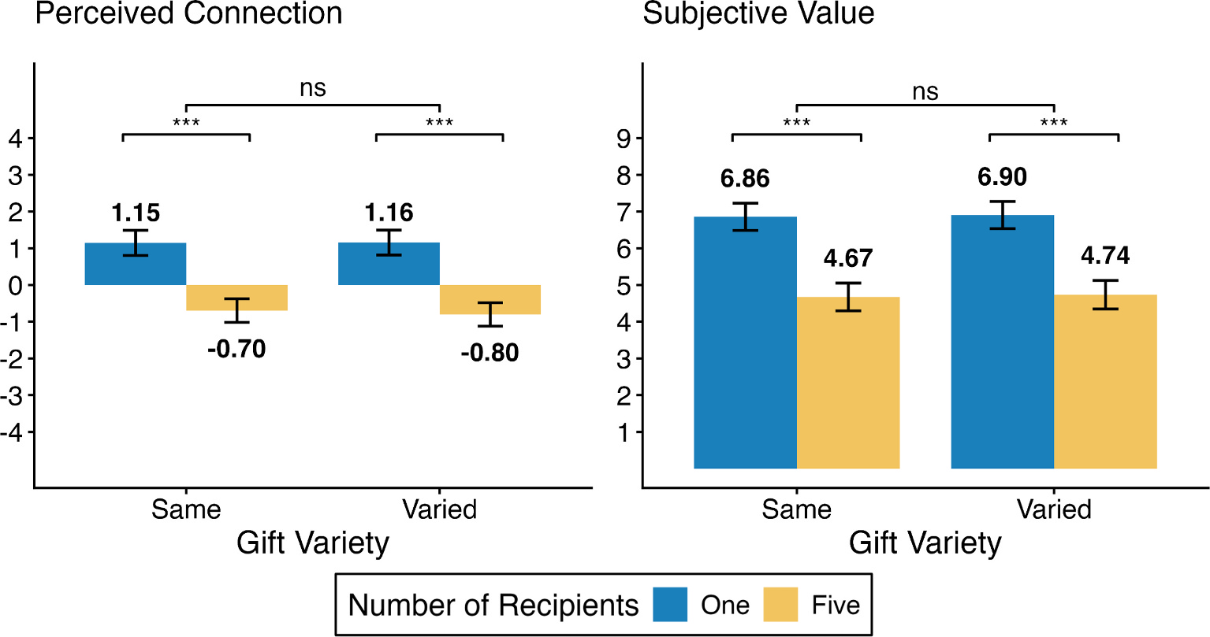
Fig. 3. Perceived Connection and Subjective Value in Study 3a. Note. Error bars display 95% confidence intervals. ns: p > .05, ***: p < .001.
We found similar results with subjective value (two measures averaged; average Cronbach’s α = .96; Fig. 3, right). Participants valued the flower more when they were the only recipient than when they were one of five recipients, both when the flowers were the same (M_{One} = 6.86, SD = 2.33 vs. M_{Five} = 4.67, SD = 2.36), paired t-test, t(149) = 11.48, p < .001, Cohen’s d = 0.94, and when they were varied (M_{One} = 6.90, SD = 2.31 vs. M_{Five} = 4.74, SD = 2.43), t(149) = 11.32, p < .001, Cohen’s d = 0.92.
On the other hand, the giver of five flowers (vs. the giver of one) was perceived to be more generous in both the same-gifts condition (M_{One} = 5.71, SD = 2.42 vs. M_{Five} = 6.63, SD = 2.17), paired t-test, t(149) = −3.85, p < .001, Cohen’s d = 0.31, and the varied-gifts condition (M_{One} = 5.76, SD = 2.32 vs. M_{Five} = 6.79, SD = 2.04), paired t-test, t(149) = −4.75, p < .001, Cohen’s d = 0.39, consistent with previous studies.
4.2. Study 3b: Perceived Connection Explains Subjective Value
4.2.1. Method
Participants. We opened the study to 460 U.S. participants from MTurk, aiming for a target sample size of 400. MTurk returned 460 complete responses from unique IP addresses. After excluding 56 participants who failed our attention checks (as pre-registered), we analyzed 404 valid responses (M_{Age} = 43.64, SD = 13.10; 50% women, 1 indicated ‘other’).
Procedure. Study 3b employed a 2 (number of recipients: one vs. three) × 2 (basis of giving: personal note vs. coin flip) between-participants design. Participants were ostensibly assigned to play the receiver in a game involving only one sender and three receivers (in reality, all participants were receivers again). We manipulated the number of total gift recipients (number of recipients) and how this number was determined (basis of giving).
Each participant first answered the same short self-disclosure question as in Study 3a. In the personal-note condition, participants were further informed that the sender would read the receivers’ answers to this question to decide whether to send each of them a virtual flower, as in the previous studies. However, in the coin-flip condition, participants were instead informed that the question was unrelated to the study, and that a computer would flip a coin for each recipient; the sender would send a flower only to those for whom the coin landed on heads.
Next, participants in the one-recipient condition learned that only they, the participant, received a flower from the sender; the other two receivers did not receive a flower. In the three-recipients condition, the message stated that all three receivers (including the participant) received a flower from the sender.
Participants rated the subjective value of the gift (“How personally valuable does the flower you received from [sender name] feel?”, 0: not at all, 6: very valuable; “How meaningful does this flower feel?”, 0: not at all, 6: very meaningful). They also rated perceived connection (on a separate page; “How strong do you think the connection between you and this sender is?”, −3: very weak, 3: very strong; “How close do you feel with this sender?”, −3: very distant, 3: very close; “How much do you agree with the following statement? There is a connection between me and this sender.”, −3: completely disagree, 3: completely agree). As additional measures, participants rated the perceived generosity of the sender (0: not generous at all, 6: very generous), how much they appreciated the sender’s gesture of sending a flower (i.e., acknowledgment of the act of generosity, distinct from the personal value of the gift; 0: not at all, 6: a lot), and how much they liked the sender (−3: dislike a lot, 3: like a lot).
At the end of the study, participants reported whether the sender had sent a flower to one or more receivers (check for the number-of-recipients manipulation) and whether the sender sent flowers based on the receivers’ answers or based on a coin flip (check for the basis-of-giving manipulation).
4.2.2. Results
Prior to the moderated-mediation analysis, we first examined perceived connection and subjective value separately. We averaged the three measures of perceived connection (Cronbach’s α = .96; Fig. 4, left). We regressed perceived connection on contrast-coded variables for the number of recipients (−1: three, 1: one), basis of giving (−1: coin flip, 1: personal note), and the interaction between the two terms.
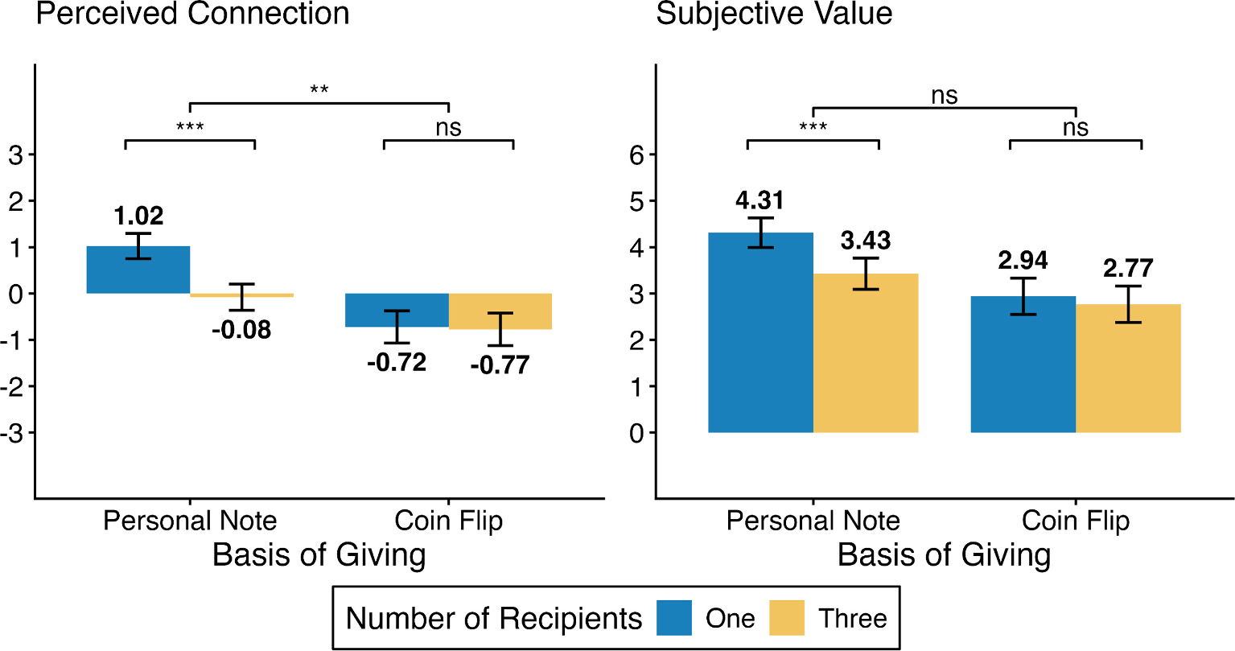
Fig. 4. Perceived Connection and Subjective Value in Study 3b. Note. Error bars display 95% confidence intervals. ns: p > .05, **: p < .01, ***: p < .001.
There was a significant main effect of the number of recipients, B = 0.29, SE = 0.080, t(400) = 3.60, p < .001, and a main effect of basis of giving, B = 0.61, SE = 0.080, t(400) = 7.62, p < .001. Further, we found a significant interaction, B = 0.26, SE = 0.080, t(400) = 3.28, p = .001. That is, rare giving was associated with greater perceived connection in the personal-note condition compared to the coin-flip condition. Exploratory simple effect analyses showed that rare giving led to a significantly stronger social connection in the personal-note condition, B = 1.10, SE = 0.22, t(400) = 4.97, p < .001, but not in the coin-flip condition, B = 0.05, SE = 0.23, t(400) = 0.22, p = .82. The basis of giving (coin flip vs. personal note) moderated the effect of the number of recipients on perceived connection, suggesting that it is unlikely that our perceived connection measure spuriously captured mechanisms independent of relationship signaling.
We also averaged the two subjective value measures (Cronbach’s α = .96; Fig. 4, right). Regressing subjective value on the same variables, we found a significant main effect of the number of recipients, B = 0.26, SE = 0.092, t(400) = 2.88, p = .004. Participants overall placed a higher subjective value on the virtual flower when they were the sole (vs. one of three) recipients. There was also a significant main effect of basis of giving, B = 0.51, SE = 0.092, t(400) = 5.52, p < .001. The subjective value of the flower was higher when it was given based on personal notes (vs. coin flip). Lastly, while the interaction between the two terms was not significant, B = 0.18, SE = 0.092, t(400) = 1.94, p = .053, the directional effect suggests the effect of the number of recipients (i.e., the higher subjective value placed on the flower when there was one recipient) was larger in the personal-note condition than in the coin-flip condition. This result suggests that the mechanisms that could have arisen based on receiving a gift by chance are unlikely to be the main driver of subjective value. Indeed, exploratory simple effect analyses showed that the effect of the number of recipients on subjective value was significant in the personal-note condition, B = 0.89, SE = 0.25, t(400) = 3.49, p < .001, but not significant in the coin-flip condition, B = 0.17, SE = 0.26, t(400) = 0.65, p = .52. Thus, being the sole flower’s recipient (vs. one of many) increased its subjective value only when the recipients were chosen deliberately (vs. based on a coin flip).
As pre-registered, we conducted a moderated-mediation analysis testing whether the mediation of subjective value by perceived connection occurs only when giving in response to a personal note, but not when giving is determined by a coin flip. We calculated estimates and standard errors using R “mediation” package, using 5,000 bootstrapped samples for each basis-of-giving condition. The indirect effect (number of recipients → perceived connection → subjective value) in the personal-note condition was statistically significant (a × b_{PersonalNote} = 0.91, 95% CI = [0.55, 1.29]). On the other hand, the indirect effect in the coin-flip condition was not significant (a × b_{CoinFlip} = 0.045, 95% CI = [−0.34, 0.43]). Consistent with our hypothesis (H3b), the difference between the indirect effects in the personal-note and coin-flip conditions was significant (a × b_{PersonalNote} − a × b_{CoinFlip} = 0.86, 95% CI = [0.34, 1.38]), confirming a significant moderated mediation: Perceived connection only mediated the effect of rare giving on subjective value when the gift could be attributed to the recipients (vs. random chance).
While subjective value and perceived connection were higher with fewer recipients, perceived giver generosity showed the opposite (though non-significant) trend: participants saw the giver as more generous with more recipients in the personal-note condition (M_{One} = 4.18, SD = 1.44 vs. M_{Three} = 4.50, SD = 1.15), t(203.81) = −1.79, p = .075, and, albeit to a lesser extent, in the coin-flip condition (M_{One} = 2.90, SD = 1.69 vs. M_{Three} = 3.10, SD = 1.65), t(190.25) = −0.82, p = .42. Additionally, while appreciation did not significantly differ by the number of recipients in either basis-of-giving condition (i.e., participants equally acknowledged the sender’s gesture; personal-note condition: M_{One} = 4.97, SD = 1.54 vs. M_{Three} = 4.71, SD = 1.27, t(205.12) = 1.34, p = .18, coin-flip condition: M_{One} = 3.64, SD = 1.93 vs. M_{Three} = 3.46, SD = 2.07, t(185.1) = 0.62, p = .53), participants liked the sender significantly more when there was only one recipient in the personal-note condition (M_{One} = 1.88, SD = 1.07 vs. M_{Three} = 1.42, SD = .97), t(207.93) = 3.30, p = .001, with no difference in the coin-flip condition (M_{One} = 0.81, SD = 0.98 vs. M_{Three} = 0.73, SD = 1.09), t(182.73) = 0.54, p = .59.
4.3. Discussion
Rare giving produced a stronger perceived connection and, in turn, greater subjective value, even in the context of minimal, symbolic gifts. This effect held regardless of whether broad givers distributed identical or varied gifts (Study 3a), suggesting that the rare giving effect observed in earlier studies is unlikely to be explained simply by the broad giver distributing identical gifts. Moreover, perceived connection mediated the effect on subjective value only when giving appeared intentional rather than random (Study 3b). This moderated mediation isolates perceived connection from non-relational explanations (e.g., scarcity, luck), supporting it as a distinct psychological mechanism rooted in relationship signaling.
5. Studies 4a-b: Moderation by the Relationship Among the Recipients
Studies 4a-b tested whether the rare giving effect is moderated by the social connection among the recipients (H4). Study 4a (pre-registration: https://aspredicted.org/7xdn-v65r.pdf) examined this in the context of charitable giving. We predicted that broad giving by firms would have a smaller negative effect on perceived connection with a focal charity when the other charities served related (similar) rather than unrelated (dissimilar) causes. Study 4b (pre-registration: https://aspredicted.org/zmnr-3cc4.pdf) tested whether the rare giving effect attenuates when the gift itself connects recipients. We predicted that when gifts link recipients to one another, such as items designed to form a set rather than standalone goods, the dilution by broad giving would be reduced, since sharing set gifts can strengthen the bonds among the recipients. As a result, an increase in the number of recipients would reduce perceived connection more for standalone gifts than for gifts that form a set.
5.1. Study 4a: Donating to Related Charity Organizations
5.1.1. Method
Participants. We opened the study to 666 U.S. participants from Prolific, aiming for a target sample size of 600. Prolific returned 656 complete responses from unique IP addresses. After excluding 56 participants who failed our attention check (as pre-registered), we analyzed 600 valid responses (M_{Age} = 37.60, SD = 12.16; 60% women, 12 indicated ‘other’).
Procedure. Study 4a employed a 2 (number of recipients: one vs. three; within-participants) × 2 (broadly-giving brands’ beneficiaries: related vs. unrelated; between-participants) mixed design. Each participant evaluated two brands: a brand that donated to one organization (one-recipient condition, i.e., rarely-giving brand) and a brand that donated to three organizations (three-recipients condition, i.e., broadly-giving brand). The three recipients of the broadly-giving brand were charities that either supported the same social cause (related condition) or distinct social causes (unrelated condition).
Participants read about a sportswear brand (referred to as Brand N or Brand A, counterbalanced). The number-of-recipients conditions were presented in counterbalanced order. In the one-recipient condition, the brand was described as donating $0.5 million to one charity organization (the “focal” organization, e.g., Helen Keller International), with a brief description of the organization’s social cause (e.g., combating blindness). In the three-recipients condition, participants read that the brand donated $0.5 million each to three different charity organizations (i.e., $1.5 million in total), one of them being the same focal organization as in the one-recipient condition. For stimulus sampling, we varied the focal organization. We used the Nature Conservancy for about half of the participants and Helen Keller International for the other half, randomly assigned. The two additional charity organizations in the three-recipients condition were chosen accordingly based on the assigned relatedness condition (e.g., in the case of Helen Keller International as the focal organization, two organizations about combating blindness [related condition] or one about the environment and the other about kidney disease [unrelated condition]; see Supplementary Materials A for the sample stimuli).
In each number-of-recipients condition, participants rated their perception of the connection between the brand and the focal organization (“How much do you think this brand is connected to [focal charity organization]?”, 1: not at all, 9: a lot). We also measured perceived generosity of the brand (i.e., corporate social responsibility) as an exploratory variable (“How socially responsible do you think this brand is overall?”, 1: not at all, 9: a lot).
As a manipulation check, participants rated perceived relatedness between the focal charity organization and each of the two additional organizations (“Please consider the following two organizations. How related do you think they are? [Focal organization] [Additional organization 1 / Additional organization 2]”, 1: not related at all, 9: very related).
5.1.2. Results
The relatedness measure confirmed that participants viewed the additional causes as more related to the focal cause in the related (vs. unrelated) condition (averaged across the two additional organizations; M_{Related} = 7.02, SD = 1.38 vs. M_{Unrelated} = 3.30, SD = 1.75), t(568.16) = 28.85, p < .001.
Participants perceived the rarely-giving brand (one-recipient condition) to be more connected to the focal organization than the broadly-giving brand (three-recipients condition) in both the unrelated condition (M_{One} = 5.93, SD = 2.47 vs. M_{Three} = 5.10, SD = 2.08), paired t-test, t(300) = 9.26, p < .001, Cohen’s d = 0.53, and the related condition (M_{One} = 6.09, SD = 2.60 vs. M_{Three} = 5.63, SD = 2.24), paired t-test, t(298) = 4.19, p < .001, Cohen’s d = 0.24 (Fig. 5).
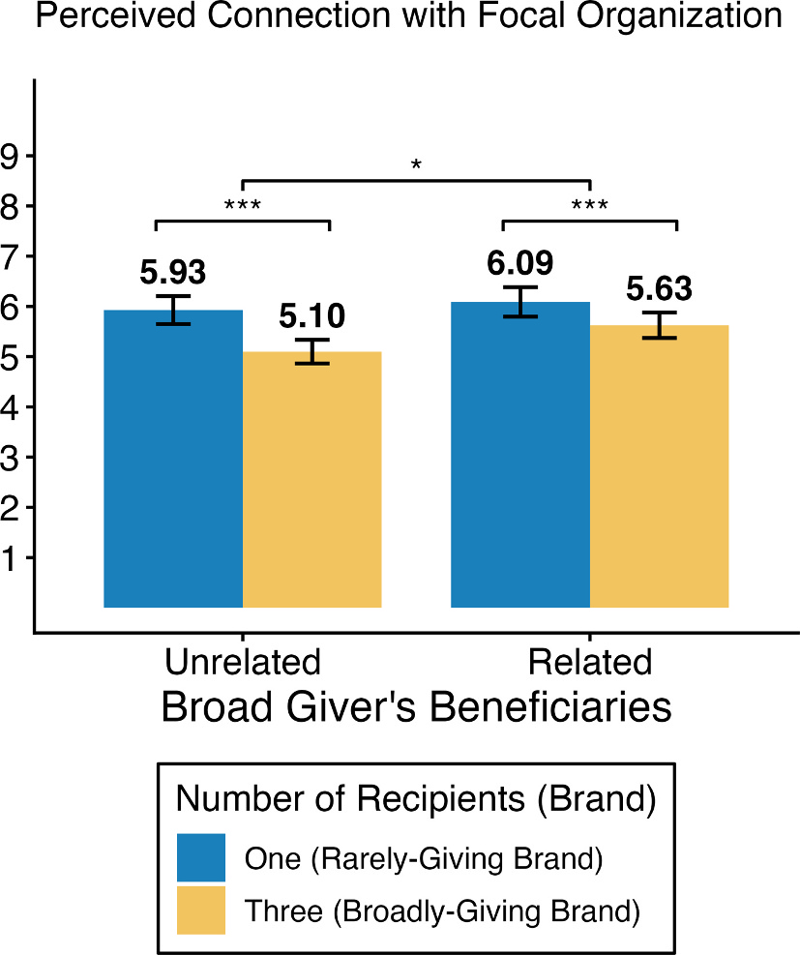
Fig. 5. Perceived Connection in Study 4a. Note. Error bars display 95% confidence intervals. *: p < .05, ***: p < .001.
To test whether the effect of the number of recipients was different across the relatedness conditions, we regressed perceived connection on the number of recipients (−1: three, 1: one), relatedness condition (−1: unrelated, 1: related), and the interaction between the two terms, controlling for the two different focal organizations used as stimuli and clustering standard errors at the participant level. As predicted, the significant main effect of the number of recipients suggested that the rarely-giving brand was perceived to be more strongly connected to the focal organization, B = 0.32, SE = 0.036, t(1195) = 9.07, p < .001. The main effect of relatedness was not significant, B = 0.16, SE = 0.089, t(1195) = 1.81, p = .071. In support of the hypothesis (H4), the interaction between the two terms was negative and significant, B = −0.091, SE = 0.036, t(1195) = −2.54, p = .011, indicating that the positive effect of rare (vs. broad) giving on perceived connection was significantly reduced when the recipients of the broad giver were related to one another rather than unrelated. In other words, broad giving reduced perceived connection less when its recipients were related.
As in previous studies, participants perceived the broadly-giving brand to be more generous (i.e., socially responsible) whether or not the beneficiaries were related (M_{One} = 6.05, SD = 1.85 vs. M_{Three} = 6.76, SD = 1.81), paired t-test, t(298) = −9.24, p < .001, Cohen’s d = 0.53, or unrelated (M_{One} = 5.89, SD = 1.82 vs. M_{Three} = 6.52, SD = 1.80), paired t-test, t(300) = −9.35, p < .001, Cohen’s d = 0.54, to the focal organization (no significant interaction, Supplementary Materials B). This suggests that giving to related recipients mitigated the dilution of social connection from broad giving, while retaining the positive effect on perceived generosity.
5.2. Study 4b: Gifts that Bring the Recipients Together
5.2.1. Method
Participants. We conducted the study with undergraduate students at a university in Singapore in exchange for course credit. A total of 417 participants completed the study during the pre-registered data collection period. We excluded 47 participants who failed the attention checks (as pre-registered) and analyzed 370 valid responses (M_{Age} = 22.04, SD = 1.44; 46% women).
Procedure. Study 4b employed a 2 (number of recipients: few vs. many; within-participants) × 2 (gift: control vs. set; between-participants) mixed design. Participants read a scenario about receiving a gift from a friend in their close board game group. The friend was described as returning from a trip overseas with either an assortment of colorful mosaic coasters (control condition) or a coordinated set of coasters that formed a complete picture (set-gift condition; Fig. 6).
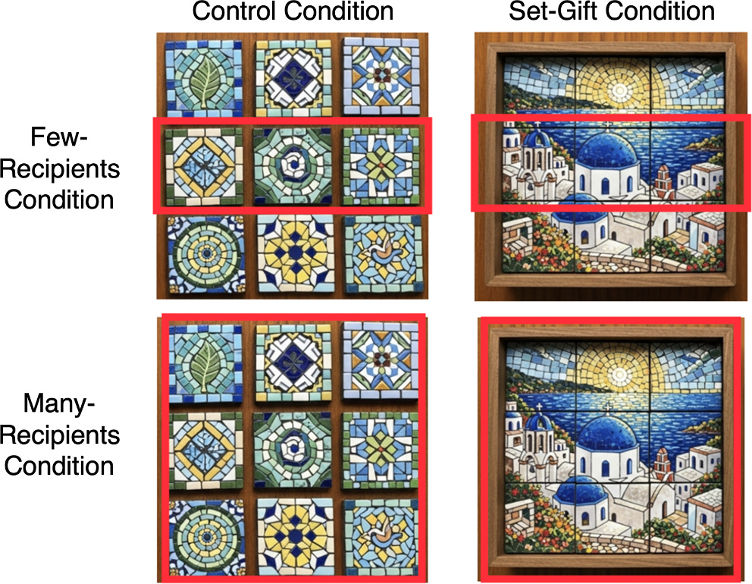
Fig. 6. The Gift Manipulations in Study 4b. Note. The images of mosaic coasters were created with ChatGPT.
In the few-recipients condition, participants read, “[name (e.g., Jamie/Taylor)] didn’t want to buy gifts for everyone, but planned to give them to just a few people. So [name] purchased just three of these coasters (as shown below). You are one of the few people to receive this coaster from [name].” In the many-recipients condition, the description varied by gift condition (control condition: “[Name] wanted to give gifts to every member of the board game group, so they purchased nine of these coasters. [Name] gave a coaster to everyone in the group, including you.”, set-gift condition: “[Name] wanted to give gifts to every member of the board game group, so they purchased the entire set of nine coasters. [Name] gave a coaster to each person in the group, including you, so the set is only complete when everyone comes together.”). An image of the coasters corresponding to each condition was presented. Participants completed both the few- and many-recipients conditions (within either control or set-gift condition) in counterbalanced order.
Next, participants rated the subjective value of the gift (“How personally valuable would this gift from [name] feel to you?”, 1: not at all, 9: very valuable; “How meaningful would this gift feel to you?”, 1: not at all, 9: very meaningful) and perceived connection (“Receiving this gift, how connected would you feel to [name]?”, 1: not at all, 9: a lot; “How would this gift make you feel toward [name]?”, −4: very distant, 4: very close; “How much does this gift suggest that [name] feels connected to you?”, 1: not at all, 9: a lot).
As a check of the gift manipulation, participants were additionally asked in the many-recipients condition, “Would this gift make you feel connected with other members of the board game group?” (1: not at all, 9: very much).
As an exploratory measure, they also rated the givers’ generosity (“How generous is [name] overall to their friends and acquaintances?”, “How inclined do you think [name] is to share or give to others in everyday life?”, 1: not at all, 9: a lot for both questions) and completed an attention check for the number-of-recipients manipulation (choosing how many coasters the friend in the scenario purchased: three, nine, or do not recall).
5.2.2. Results
Supporting the set manipulation, participants reported feeling more connected to other members of the board game group in the set-gift condition, where each member received a piece of the same set, than in the control condition (M_{Set} = 7.22, SD = 1.58 vs. M_{Control} = 5.95, SD = 2.09), t(341.06) = 6.55, p < .001.
We averaged the three measures of perceived connection (average Cronbach’s α = .90; Fig. 7, left). We regressed perceived connection on the number of recipients (−1: many, 1: few), gift condition (−1: control, 1: set), their interaction, and participant-level random intercepts (i.e., a mixed-effects model). We found a significant main effect of the number of recipients, B = 0.38, SE = 0.030, t(368) = 12.58, p < .001, and no main effect for the gift condition, B = 0.049, SE = 0.060, t(368) = 0.83, p = .41. In support of the hypothesis (H4), the interaction between the two terms was negative and significant, B = −0.14, SE = 0.030, t(368) = −4.68, p < .001, indicating that the difference in perceived connection based on the number of recipients was smaller in the set-gift (vs. control) condition. Sharing gifts that comprised a set with the group mitigated the dilution of connection with the individual recipient, resulting in attenuation of the rare giving effect.
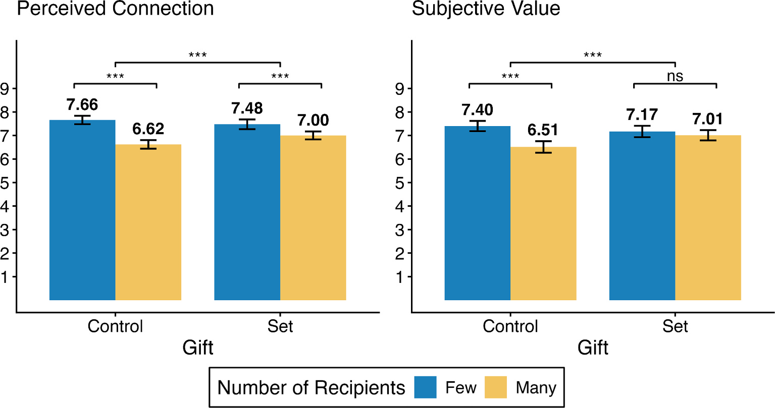
Fig. 7. Perceived Connection and Subjective Value in Study 4b. Note. Error bars display 95% confidence intervals. ns: p > .05, ***: p < .001.
Simple effect analyses found that the effect of the number of recipients (recoded as 0: many, 1: few) was significant in both the control condition, B = 1.04, SE = 0.085, t(368) = 12.17, p < .001, and the set-gift condition (albeit smaller), B = 0.47, SE = 0.085, t(368) = 5.60, p < .001.
We repeated the same analyses with subjective value (two measures averaged; average Cronbach’s α = .90; Fig. 7, right) and found a similar pattern. There was a significant main effect of the number of recipients, B = 0.26, SE = 0.037, t(368) = 7.11, p < .001, and no main effect of the gift condition, B = 0.066, SE = 0.075, t(368) = 0.88, p = .38. Consistent with the results on perceived connection, the interaction between the two terms was negative and significant, B = −0.18, SE = 0.037, t(368) = −4.96, p < .001. The simple effect of the number of recipients on subjective value was significant in the control condition, B = 0.89, SE = 0.10, t(368) = 8.51, p < .001, and not significant in the set-gift condition, B = 0.16, SE = 0.10, t(368) = 1.53, p = .13.
We tested whether the moderation in subjective value is likely to be attributable to perceived connection (consistent with our theory) using moderated-mediation analysis (using 5,000 bootstrapped clustered samples). The indirect effect (number of recipients → perceived connection → subjective value) was statistically significant in both the control condition (a × b_{Control} = 1.03, 95% CI = [0.91, 1.16]) and the set-gift condition (a × b_{Set} = 0.47, 95% CI = [0.33, 0.63]). However, the indirect effect was significantly smaller in the set-gift condition (a × b_{Control} − a × b_{Set} = 0.55, 95% CI = [0.37, 0.74]), confirming a significant moderated mediation.
Lastly, we examined perceived generosity (two measures averaged; average Cronbach’s α = .85). As in previous studies, participants perceived the giver to be more generous in the many-recipients condition than in the few-recipients condition in both the control condition (M_{Few} = 5.84, SD = 1.54 vs. M_{Many} = 7.66, SD = 1.25), paired t-test, t(183) = −15.84, p < .001, Cohen’s d = 1.17, and in the set-gift condition (M_{Few} = 5.41, SD = 1.60 vs. M_{Many} = 7.59, SD = 1.09), paired t-test, t(185) = −18.79, p < .001, Cohen’s d = 1.22.
5.3. Discussion
We replicated the rare giving effect on perceived connection, but found it was moderated by the social connection among recipients. The negative effect of the number of recipients was significantly smaller when recipients were perceived as related (Study 4a) and when the gifts themselves connected the recipients (Study 4b).
6. Studies 5a-b: Reciprocating to the Rare Giver
In our final studies, we examined a downstream consequence of rare giving: reciprocation. Giving is often motivated by the expectation of reciprocity, both for self-gain and for sustaining future relationships. However, we predicted that broad givers, despite demonstrating greater generosity overall, would be less likely to receive reciprocation (H5).
In Study 5a (pre-registration: https://aspredicted.org/hs58-6rjq.pdf), we returned to our minimal giving paradigm with symbolic gifts (e.g., flowers, as in Studies 3a-b) to examine reciprocation in interpersonal giving. We predicted that recipients would prefer to reciprocate, by sending a gift in return, to a rare giver rather than to a broad giver.
In Study 5b (pre-registration: https://aspredicted.org/hqq8-qw8x.pdf), we tested an implication of our hypothesis in the context of corporate charitable giving. Additional giving should generally be viewed positively and increase purchase intentions among those who recognize the firm’s generosity, especially by observers who are not part of the beneficiaries. However, purchase intentions can also be influenced by motivations to reciprocate toward the firm (Morales, 2005; Palmatier et al., 2009). Thus, when consumers are the beneficiaries (e.g., residents of a state receiving donations), we expect reciprocity to play a greater role in purchase preference. In turn, the preference for the broadly-giving firm (vs. rarely-giving firm) could diminish due to perceiving the firm’s connection with the participant’s state to be weaker.
6.1. Study 5a: Reciprocating a Flower to the Rare Giver
6.1.1. Method
Participants. We opened the study to 130 U.S. participants from MTurk, aiming for a target sample size of 120. MTurk returned 129 complete responses from unique IP addresses. After excluding nine participants who failed our attention checks (as pre-registered), we analyzed 120 valid responses (M_{Age} = 38.68, SD = 10.93; 42% women, 1 indicated ‘other’).
Procedure. Like Study 2b, participants were ostensibly assigned to play the receiver in a group of two senders and three receivers (in reality, all participants were receivers again). Instead of real gifts, we employed the minimal giving paradigm as in Studies 3a-b (exchanging virtual flowers). Instead of initials, animal names were used as nicknames for the senders and receivers.
After answering a short question to be sent to the senders (writing about their favorite movie), participants were shown a pre-programmed result of the senders’ decisions. One sender was described as sending a flower only to the participant (the rare giver), while the other sender sent flowers to all three receivers (the broad giver), including the participant (see Supplementary Materials A for the sample stimuli).
First, participants chose to return one of the two flowers they received, thereby keeping the other, similar to Study 2b. In this study, however, we specified that the flower they chose to return would be discarded and that the senders would not be informed of their decision. Next, participants selected which of the two senders they would like to send a different flower to, as a measure of reciprocation. They also briefly explained the reasons behind their choices for both decisions (exploratory; data available on OSF).
Next, participants answered six questions in randomized order. As in previous studies, they rated how meaningful it was for each sender to send them a flower (1: not meaningful at all, 7: very meaningful) and how valuable the flower they received was (1: not valuable at all, 7: very valuable) as additional measures of subjective value. They also rated perceived connection by rating their feelings of connection to each sender after the activity (1: not connected at all, 7: very connected), and as a related measure, predicted how much each sender liked them (−3: very much dislikes you, 3: very much likes you).
Finally, participants rated the generosity of each sender (−3: very selfish, 3: very generous). Relatedly, we elicited predictions on how likely each sender would be to send a flower to them again in the event of another round of this activity (assuming the senders had not yet received a flower in return; 1: not likely at all, 7: very likely).
6.1.2. Results
Participants reported higher perceived connection with the rare (vs. broad) giver (M_{Rare} = 5.53, SD = 1.68 vs. M_{Broad} = 4.03, SD = 1.57), paired t-test, t(119) = 8.85, p < .001, Cohen’s d = 0.81, which was consistent with their inference about how much each sender liked the participant (M_{Rare} = 2.15, SD = 1.15 vs. M_{Broad} = 0.98, SD = 1.04), paired t-test, t(119) = 9.70, p < .001, Cohen’s d = 0.89.
Critically, in support of our hypothesis (H5), the reciprocation decision was consistent with gift valuation and perceived connection: 75% (90/120) of the participants chose to send a flower to the rare giver, instead of the broad giver (greater than 50%), χ²(1) = 29.01, p < .001. Participants were more likely to reciprocate to the giver who sent out fewer gifts.
We also replicated our prior results on gift valuation: The majority (81%, 97/120) chose to keep the flower from the rare giver (greater than 50%), χ²(1) = 44.41, p < .001, and also rated the rare giver’s flower to be more valuable (M_{Rare} = 5.82, SD = 1.81 vs. M_{Broad} = 4.27, SD = 1.81), paired t-test, t(119) = 8.56, p < .001, Cohen’s d = 0.78, and more meaningful (M_{Rare} = 5.98, SD = 1.44 vs. M_{Broad} = 4.09, SD = 1.75), paired t-test, t(119) = 9.85, p < .001, Cohen’s d = 0.90.
Further, perceived generosity showed the opposite pattern: The broad giver was rated as more generous than the rare giver (M_{Rare} = 0.30, SD = 1.48 vs. M_{Broad} = 2.47, SD = 0.93), paired t-test, t(119) = −12.56, p < .001, Cohen’s d = 1.15. Participants also predicted that they were more likely to receive a flower again from the broad giver than from the rare giver (M_{Rare} = 5.37, SD = 1.37 vs. M_{Broad} = 5.93, SD = 1.35), paired t-test, t(119) = −3.11, p = .002, Cohen’s d = 0.28, consistent with perceived generosity. These results again illustrate that the perceptions of overall generosity are distinctive from perceived connection, with potential consequences to the givers: Broad givers may be seen as more generous, but their giving may be less likely to be reciprocated.
6.2. Study 5b: Observing Additional Giving to Other States
6.2.1. Method
Participants. We opened the study to 280 U.S. participants from MTurk, aiming for a target sample size of 250. MTurk returned 277 complete responses from unique IP addresses. We excluded 21 participants who failed our additional attention check at the end of the survey, one participant who provided inconsistent responses when asked about the state they currently reside in (asked twice during the survey), and another participant who reported that they had lived in their current state for less than two months (as pre-registered). A final sample of 254 valid responses was analyzed (M_{Age} = 40.51, SD = 12.75; 56% women, 2 indicated ‘other’).
Procedure. Participants were randomly assigned to one of two (focal state: own-state vs. other-state) between-participants conditions. Before beginning the survey, participants first answered which state in the U.S. they currently reside in. Participants read short descriptions of two sportswear brands. Brand A (the rarely-giving brand) was described as supporting one specific state (focal state), although it was not explicitly stated that it was the only state the brand was supporting. Brand N (the broadly-giving brand) was described as supporting the focal state (same as Brand A) and three additional states. To prevent participants from assuming that the rarely-giving brand made a larger contribution to the focal state, we further specified that both brands contributed $0.5 million to each state (thus, the broadly-giving brand contributed $2 million in total).
As the focal state (the state both brands supported in common), in the own-state condition, we used the participant’s own state. In the other-state condition, a randomly selected state (for each participant) that was not the participant’s state was assigned as the focal state. The three other states were randomly selected in both conditions for every participant. Therefore, in the own-state condition, each participant viewed two brands—the rarely-giving brand and the broadly-giving brand—both contributing to the participant’s state, while in the other-state condition, neither brand contributed to the participant’s state.
Participants indicated which brand they would prefer to purchase from between Brand A and Brand N. Next, on a separate page, participants rated how connected each of the brands was to the focal state (“How much do you think [Brand A / Brand N] is connected to the state of [focal state]?”, 1: not at all, 7: a lot).
Additionally, participants rated their relative perception of corporate social responsibility of the two brands as a measure of perceived generosity (“Which brand do you think is more socially responsible overall?”, −4: Brand A [rarely-giving brand], 4: Brand N [broadly-giving brand]).
6.2.2. Results
In both conditions, the perceived connection between the recipient and the firm was reduced by broad giving. Overall, participants rated the rarely-giving brand to be more connected with the focal state than the broadly-giving brand (M_{Rare} = 6.17, SD = 1.18 vs. M_{Broad} = 4.17, SD = 1.14), paired t-test, t(253) = 21.14, p < .001, Cohen’s d = 1.33. The results were consistent when we examined these measures in each condition separately (own-state condition: M_{Rare} = 6.02, SD = 1.21 vs. M_{Broad} = 4.21, SD = 1.12, paired t-test, t(127) = 13.70, p < .001, Cohen’s d = 1.21; other-state condition: M_{Rare} = 6.32, SD = 1.14 vs. M_{Broad} = 4.13, SD = 1.16, paired t-test, t(125) = 16.39, p < .001, Cohen’s d = 1.46).
Turning to brand preference, however, the majority of the participants in the other-state condition selected the broadly-giving brand to purchase from, with only 5% (6/126) of the participants choosing the rarely-giving brand. This establishes the baseline preference between the two brands when the participants are unrelated to the recipients of the brands: As third-party observers, participants generally preferred the broadly-giving (i.e., the more generous) brand. However, this preference for the broadly-giving brand was attenuated in the own-state condition, with a significantly larger proportion of participants (33%, 42/128) choosing the rarely-giving brand, Fisher’s exact test, OR = 9.69, p < .001 (results are consistent when a two-sample test of proportions is used as in other studies: χ²(1) = 30.79, p < .001), Cohen’s h = 0.78. The reduced preference for the broadly-giving brand aligns with our hypothesis on reciprocity (H5): When individuals are part of the beneficiaries, they are more likely to reciprocate toward the rarely-giving brand, as they are likely to care about the brand’s connection with them, not just about its overall generosity. Consistent with this intuition, a supplementary exploratory analysis showed that brand preference tracked the brands’ connection to the focal state in the own-state condition, but not in the other-state condition (see details in Supplementary Materials B).
As in previous studies, the effect of broad giving on perceived generosity was in the opposite direction of its effect on perceived connection. The broadly-giving brand (giving to four states) was perceived as relatively more socially responsible than the rarely-giving brand in both the own-state condition (M = 1.22, SD = 1.93), t(127) = 7.15 (compared to the midpoint 0 which indicates indifference), p < .001, and the other-state condition (M = 1.69, SD = 1.51), t(125) = 12.57, p < .001.
6.3. Discussion
Recipients were more likely to reciprocate with a flower to a rare giver than to a broad giver (Study 5a). For firms’ social contributions, even when the broadly-giving firm was initially preferred, this preference weakened among participants who were part of the beneficiaries (Study 5b). Together, Studies 5a-b illustrate the potential negative consequences for the broad givers: They may incur more resources than rare givers by giving to many, but receive less in return.
7. General Discussion
Generosity is costly. Giving to more recipients requires additional time, money, and energy. This research finds that greater generosity, when achieved by increasing the number of recipients, can also be costly in terms of signaling social connection. Broad giving reduced the perceived connection between a giver and each individual recipient, even when broad givers spent more resources overall (holding the value of each gift or contribution constant) or gave higher-valued gifts (Study 2b). In turn, participants valued gifts from a rare giver more (Study 2a) and were more likely to keep them (Study 2b). These effects were mediated by perceived social connection and unlikely to be driven by the gifts being generic (Study 3a) or the mere statistical rarity of receiving a gift (Study 3b). Moreover, increased social connection among recipients mitigated the effect: the negative effect of broad giving on perceived connection was reduced when recipients shared related purposes (i.e., charities for a common cause, Study 4a) or when the gifts themselves brought the recipients into a more cohesive group (i.e., by forming a set, Study 4b). Finally, recipients were more likely to reciprocate to rare givers than to broad givers, sometimes even favoring companies that made more limited charitable contributions (Studies 5a-b).
We observed consistent effects using between-participants, separate evaluations, in which participants evaluated only one giver (Studies 1, 2a, 3b), and within-participants evaluations, where participants could compare rare and broad givers, whether side by side (Studies 2b, 5a-b) or separately (Studies 3a, 4a-b). The between-participants separate-evaluation results indicate that the rare giving effect generalizes to situations where people may not explicitly compare rare versus broad giving. The results from within-participants studies suggest that people consider the number of recipients even when they are aware that the gifts’ objective value is identical or the broad giver’s gift has higher value (as in Study 2b).
The rare giving effect persisted when participants were aware that broad and rare givers had equal resources to distribute (e.g., Study 3a, where both givers had the same number of flowers to distribute). They could not assume that rare givers were sacrificing a larger share of their resources. Thus, differences in inferred capacity or effort are unlikely explanations.
Further, our findings cannot be explained by reduced perceived authenticity from broad giving. While generosity appears less authentic when it is attributed to self-interest or strategic intent, such as enhancing one’s own reputation (Berman et al., 2015; Berman & Silver, 2022), broad givers were still consistently perceived as more generous across our studies. Importantly, our effects held even when givers’ identities were undisclosed to recipients (Studies 1, 2b, 3a-b, 5a), so that broad giving could not plausibly be attributed to self-presentation motives.
7.1. Implications
Social connections matter for overall life satisfaction (Diener & Seligman, 2002), as well as a wide range of social and organizational outcomes. Social relationships predict longevity (Holt-Lunstad et al., 2010). At work, stronger coworker relationships are linked to job satisfaction, job involvement, organizational citizenship behaviors, and absence of negative outcomes, such as role conflict, absenteeism, and intention to quit (Chiaburu & Harrison, 2008; Winstead et al., 1995). Brands that build strong social connections with their customers enjoy greater customer loyalty and long-term customer value (Christopher et al., 2013).
Unlike romantic relationships, where exclusivity is highly valued (Eastwick et al., 2007), forming multiple social ties is generally encouraged in workplace and personal contexts (Collins et al., 2022; Podolny & Baron, 1997). Thus, in non-romantic settings, there is a trade-off between expanding one’s social network and maintaining the strength of each social connection. Consequently, givers must balance these considerations while managing their resources effectively. Importantly, our results suggest that reciprocity is not strictly quid pro quo, as typically assumed in dyadic social exchange frameworks (Blau, 1964; Foa & Foa, 1980). Broad givers may contribute more resources but not accrue benefits proportional to their contributions. In extreme cases, as with Timon, broad givers may expend more resources overall but foster only shallow social connections, failing to reap reciprocal benefits.
Our results relate in part to the zero-sum mindset—the assumption of a “fixed pie” of relational resources, even when such resources may be abundant or flexible (Davidai & Tepper, 2023; Meegan, 2010). This mindset applies not only to tangible resources but also to psychological ones like empathy (Hasson et al., 2022) and romantic love (Burleigh et al., 2017). We find that strengthening a bond with one friend may be seen as detracting from others, consistent with the idea that people may perceive others’ relational resources, including time, attention, and emotional investment, as limited. Even when resources do not, in actuality, spread thin when broadly distributed (i.e., the value of individual gifts is constant), people infer weaker ties.
Our findings also highlight a potential trade-off between reputation and relationships. While broad giving can enhance perceptions of a giver’s overall generosity, it may come at the cost of signaling weaker connections with each recipient. Thus, givers must strategically balance breadth and focus—deciding whether to prioritize building a broad reputation or cultivating deeper, more meaningful connections with fewer individuals. This choice likely depends on whether the giver would gain more from enhancing reputation or from deepening relationships in the given context. In many cases, people are motivated to enhance their image and status, especially in organizational settings where impression management is common (Bolino et al., 2016). Individuals may seek to boost their reputation by being generous to current or future colleagues. Firms also often aim to be seen as socially responsible. In these cases, broad giving can be advantageous. For example, a job applicant evaluated by a hiring committee or a company aiming to enhance its brand image may benefit from appearing broadly generous. However, when the main benefit comes from the strength of social connections, such as reciprocal gains, broad generosity can backfire. Study 5b illustrates this tension: most participants preferred companies that donated to more states and contributed larger total amounts, especially when they were not part of the beneficiaries (i.e., observers). Yet this preference weakened among participants who lived in recipient states, where the donations directly affected their social group. When reciprocation or close relationships are expected, broad giving may yield diminished returns, as reputational benefits are offset by weaker social connections. In these situations, rare giving focused on fewer recipients can be more effective. Alternatively, our moderation results suggest that strategically selecting socially connected recipients and highlighting these connections may help balance the reputational and relational gains from broad giving.
Finally, our findings have implications for recipients deciding how to invest in future relationships. Stronger perceived connections tend to foster more positive attitudes and a greater desire to build relationships. Our participants liked the rare giver more, reflecting perceived social connection, even though they recognized the broad giver as more generous and more likely to give again. This suggests that when choosing whom to befriend, recipients may shy away from givers like Timon of Athens—those who give broadly and often—because their giving feels less personal, even if such individuals are the ones more likely to show up with resources, help, and support. For example, a coworker who consistently offers acts of kindness to everyone might be overlooked as a potential friend in favor of a colleague who helps only a few and thus helps others less frequently overall.
7.2. Remaining Questions and Directions for Future Research
A remaining question is whether givers intuit the rare giving effect. In exploratory results in Study 1 (Supplementary Materials B), we observed that givers did not anticipate (or at least underestimated) the negative effect of broad giving on perceived connection. If this misprediction is systematic, it may lead to suboptimal giving decisions when givers are concerned with establishing or strengthening social connections. Alternatively, if givers are aware of this effect, they might be motivated to hide their gifts from their social network to ensure that each recipient feels like a rare recipient.
Future research can also explore additional boundary conditions beyond the intentional selection of recipients. Context- or relationship-specific giving norms may play a role. For example, when there is an expectation to give a gift (e.g., when attending a birthday party), giving may no longer signal a special social connection. Additionally, recipients’ prior attitudes toward the giver can significantly shape how giving is interpreted. While our studies involved recipients who generally felt positive or neutral toward the giver, the effects of rare giving may differ when recipients hold negative feelings or view the relationship as unwanted, such as if the giver is an ex-partner or a disliked coworker. In such cases, rare giving, which signals strong relational intent, might be perceived as intrusive, causing discomfort and reducing the gift’s perceived value.
Relatedly, there may be ways to mitigate the dilution effects of broad giving, in addition to highlighting or reinforcing connections among recipients. Givers could increase the frequency and consistency of giving to the same recipient (Schaumberg & Lin, 2025) or choose gifts that better signal connection, such as highly personalized items (Galak et al., 2016; Paolacci et al., 2015; Pizzetti et al., 2024) or experiential rather than material gifts (Chan & Mogilner, 2016; Goodman & Lim, 2018). It remains to be explored which of these strategies is most effective, and to what extent they should be employed (e.g., how personalized gifts need to be or how frequently giving should occur) to maintain the strength of social connections when giving broadly.
Future research could also examine the generalizability of our findings across cultures and different types of behaviors. Although our samples included participants from the United States and Singapore, culture-specific norms surrounding relationships and giving may moderate the rare giving effect in other populations. Further, while we empirically focused on gift-giving and donations, our theory extends to other prosocial behaviors, such as helping, mentoring, or cooperation. However, the implications in this organizational context may depend on expectations. For example, cooperation may be viewed as responsibility rather than as a signal of connection, and thus may not be subject to the rare giving effect. Conversely, another question involves negative organizational citizenship behavior or ethically ambiguous acts (e.g., lying to a supervisor to benefit a colleague). If unethical helping behaviors are directed toward many (vs. few) coworkers, they might signal weaker social connections without enhancing perceptions of generosity and may even provoke negative reactions, such as discomfort or reduced perceptions of morality and loyalty to the organization.
A final question is whether the rare giving effect extends to behaviors that are not primarily intended to signal relationship interest, but rather convey non-relational positive evaluation. For example, a supervisor may hand out gifts as recognition of employees’ good performance rather than as a personal regard. If the rare giving effect is partly driven by recipients feeling special for being among a few who are positively evaluated, and if this positive affect transfers to the giver, such recognition may still increase perceived closeness to the supervisor. However, the effect of such rare positive evaluations may depend on attribution. When employees attribute the recognition to the supervisor’s subjective appreciation (e.g., “my supervisor values my work”), rare recognition may strengthen relational closeness. In contrast, when recognition is attributed to objective performance criteria or to the self (e.g., “I did great and deserve the recognition”), employees may experience pride or satisfaction, but may not necessarily feel closer to the supervisor.
8. Organizational Relevance and Contribution Statement
This research informs how individuals and organizations can use generosity more strategically, depending on whether their goal is to build relationships or enhance their reputation. In many settings—among coworkers, between leaders and subordinates, or between brands and consumers—acts of giving are expected to foster goodwill. However, giving broadly to many recipients may unintentionally weaken the perceived connection with any one recipient. In workplace contexts, private, targeted gestures may be more effective for strengthening interpersonal bonds than broad, public displays. Importantly, the most effective approach may depend on the giver’s objective. When the aim is to boost general reputation—such as appearing generous to a wide audience—broader giving may be more advantageous. For organizations and marketers, this suggests that the effectiveness of publicizing generosity (e.g., charitable giving or gifts to employees) depends on what the audience focuses on: overall generosity (e.g., corporate social responsibility or general concern for employee welfare) versus a specific relational connection (e.g., support for a particular cause or a specific group). For instance, messaging that highlights a company’s contributions to many social causes may resonate more with consumers who are not particularly attached to any one issue but may be less effective for those deeply invested in a specific cause.
Acknowledgement
The authors gratefully acknowledge financial support from the University of Chicago Booth School of Business. Pre-registrations, data, code, and materials are available in the OSF repository: https://osf.io/38dx6.
Appendix A. Supplementary Data
Supplementary data to this article can be found online at https://doi.org/10.1016/j.obhdp.2026.104478.
References
Adler, P. S., & Kwon, S.-W. (2002). Social capital: Prospects for a new concept. The Academy of Management Review, 27(1), 17–40. https://doi.org/10.2307/4134367
Aknin, L. B., Barrington-Leigh, C. P., Dunn, E. W., Helliwell, J. F., Burns, J., Biswas-Diener, R., Kemeza, I., Nyende, P., Ashton-James, C. E., & Norton, M. I. (2013). Prosocial spending and well-being: Cross-cultural evidence for a psychological universal. Journal of Personality and Social Psychology, 104(4), 635–652. https://doi.org/10.1037/a0031578
Aknin, L. B., Dunn, E. W., Sandstrom, G. M., & Norton, M. I. (2013). Does social connection turn good deeds into good feelings? On the value of putting the “social” in prosocial spending. International Journal of Happiness and Development, 1(2), 155–171. https://doi.org/10.1504/IJHD.2013.055643
Aknin, L. B., & Human, L. J. (2015). Give a piece of you: Gifts that reflect givers promote closeness. Journal of Experimental Social Psychology, 60, 8–16. https://doi.org/10.1016/j.jesp.2015.04.006
Anderson, J. R. (1974). Retrieval of propositional information from long-term memory. Cognitive Psychology, 6(4), 451–474.
Anderson, J. R., & Bower, G. (2014). Human associative memory. Psychology Press.
Ariely, D., Bracha, A., & Meier, S. (2009). Doing good or doing well? Image motivation and monetary incentives in behaving prosocially. American Economic Review, 99(1), 544–555. https://doi.org/10.1257/aer.99.1.544
Aron, A., Melinat, E., Aron, E. N., Vallone, R. D., & Bator, R. J. (1997). The experimental generation of interpersonal closeness: A procedure and some preliminary findings. Personality and Social Psychology Bulletin, 23(4), 363–377. https://doi.org/10.1177/0146167297234003
Ashworth, L., Rath, S., & Robitaille, N. (2025). Gifts that keep on giving: Reflected appraisals from gifts and their role in identity and choice. Journal of Experimental Social Psychology, 118, Article 104717. https://doi.org/10.1016/j.jesp.2024.104717
Basyouni, R., & Parkinson, C. (2022). Mapping the social landscape: Tracking patterns of interpersonal relationships. Trends in Cognitive Sciences, 26(3), 204–221. https://doi.org/10.1016/j.tics.2021.12.006
Belk, R. W. (1976). It’s the thought that counts: A signed digraph analysis of gift-giving. Journal of Consumer Research, 3(3), 155–162.
Bereczkei, T., Birkas, B., & Kerekes, Z. (2007). Public charity offer as a proximate factor of evolved reputation-building strategy: An experimental analysis of a real-life situation. Evolution and Human Behavior, 28(4), 277–284. https://doi.org/10.1016/j.evolhumbehav.2007.04.002
Berman, J. Z., Barasch, A., Levine, E. E., & Small, D. A. (2018). Impediments to effective altruism: The role of subjective preferences in charitable giving. Psychological Science, 29(5), 834–844. https://doi.org/10.1177/0956797617747648
Berman, J. Z., Levine, E. E., Barasch, A., & Small, D. A. (2015). The braggart’s dilemma: On the social rewards and penalties of advertising prosocial behavior. Journal of Marketing Research, 52(1), 90–104. https://doi.org/10.1509/jmr.14.0002
Berman, J. Z., & Silver, I. (2022). Prosocial behavior and reputation: When does doing good lead to looking good? Current Opinion in Psychology, 43, 102–107. https://doi.org/10.1016/j.copsyc.2021.06.021
Bernard, H. R., Killworth, P. D., & Sailer, L. (1979). Informant accuracy in social network data IV: A comparison of clique-level structure in behavioral and cognitive network data. Social Networks, 2(3), 191–218. https://doi.org/10.1016/0378-8733(79)90014-5
Billig, M., & Tajfel, H. (1973). Social categorization and similarity in intergroup behaviour. European Journal of Social Psychology, 3(1), 27–52. https://doi.org/10.1002/ejsp.2420030103
Blau, P. M. (1964). Justice in social exchange. Sociological Inquiry, 34(2), 193–206. https://doi.org/10.1111/j.1475-682X.1964.tb00583.x
Bolino, M., Long, D., & Turnley, W. (2016). Impression management in organizations: Critical questions, answers, and areas for future research. Annual Review of Organizational Psychology and Organizational Behavior, 3(1), 377–406. https://doi.org/10.1146/annurev-orgpsych-041015-062337
Borgatti, S. P., Mehra, A., Brass, D. J., & Labianca, G. (2009). Network analysis in the social sciences. Science, 323(5916), 892–895. https://doi.org/10.1126/science.1165821
Brands, R. A. (2013). Cognitive social structures in social network research: A review. Journal of Organizational Behavior, 34(S1), S82–S103. https://doi.org/10.1002/job.1890
Brief, A. P., & Motowidlo, S. J. (1986). Prosocial organizational behaviors. The Academy of Management Review, 11(4), 710–725. https://doi.org/10.2307/258391
Burleigh, T. J., Rubel, A. N., & Meegan, D. V. (2017). Wanting ‘the whole loaf’: Zero-sum thinking about love is associated with prejudice against consensual non-monogamists. Psychology & Sexuality, 8(1–2), 24–40. https://doi.org/10.1080/19419899.2016.1269020
Camerer, C. (1988). Gifts as economic signals and social symbols. American Journal of Sociology, 94, S180–S214. https://doi.org/10.1086/228946
Chan, C., & Mogilner, C. (2016). Experiential gifts foster stronger social relationships than material gifts. Journal of Consumer Research, ucw067. https://doi.org/10.1093/jcr/ucw067
Chancellor, J., Margolis, S., Jacobs Bao, K., & Lyubomirsky, S. (2018). Everyday prosociality in the workplace: The reinforcing benefits of giving, getting, and glimpsing. Emotion, 18(4), 507–517. https://doi.org/10.1037/emo0000321
Chiaburu, D. S., & Harrison, D. A. (2008). Do peers make the place? Conceptual synthesis and meta-analysis of coworker effects on perceptions, attitudes, OCBs, and performance. Journal of Applied Psychology, 93(5), 1082–1103. https://doi.org/10.1037/0021-9010.93.5.1082
Christopher, M., Payne, A., & Ballantyne, D. (2013). Relationship marketing. Taylor & Francis.
Chu, C. K., & Shu, S. B. (2023). Mementos and the endowment effect. Journal of Behavioral Decision Making, 36(1), e2295.
Cialdini, R. B. (1987). Influence (Vol. 3). A. Michel Port Harcourt.
Collins, H. K., Hagerty, S. F., Quoidbach, J., Norton, M. I., & Brooks, A. W. (2022). Relational diversity in social portfolios predicts well-being. Proceedings of the National Academy of Sciences, 119(43), Article e2120668119. https://doi.org/10.1073/pnas.2120668119
Cropanzano, R., & Mitchell, M. S. (2005). Social exchange theory: An interdisciplinary review. Journal of Management, 31(6), 874–900. https://doi.org/10.1177/0149206305279602
Davidai, S., & Tepper, S. J. (2023). The psychology of zero-sum beliefs. Nature Reviews Psychology, 2(8), 472–482. https://doi.org/10.1038/s44159-023-00194-9
Davis, J. L., & Rusbult, C. E. (2001). Attitude alignment in close relationships. Journal of Personality and Social Psychology, 81(1), 65–84. https://doi.org/10.1037/0022-3514.81.1.65
Deckop, J. R., Cirka, C. C., & Andersson, L. M. (2003). Doing unto others: The reciprocity of helping behavior in organizations. Journal of Business Ethics, 47(2), 101–113. https://doi.org/10.1023/A:1026060419167
Diener, E., & Seligman, M. E. P. (2002). Very happy people. Psychological Science, 13(1), 81–84. https://doi.org/10.1111/1467-9280.00415
Eastwick, P. W., Finkel, E. J., Mochon, D., & Ariely, D. (2007). Selective versus unselective romantic desire: Not all reciprocity is created equal. Psychological Science, 18(4), 317–319. https://doi.org/10.1111/j.1467-9280.2007.01897.x
Eisenberg, N. (1991). Meta-analytic contributions to the literature on prosocial behavior. Personality and Social Psychology Bulletin, 17(3), 273–282.
Ellingsen, T., & Johannesson, M. (2011). Conspicuous generosity. Journal of Public Economics, 95(9), 1131–1143. https://doi.org/10.1016/j.jpubeco.2011.05.002
Flynn, F. J. (2003). How much should I give and how often? The effects of generosity and frequency of favor exchange on social status and productivity. Academy of Management Journal, 46(5), 539–553.
Flynn, F. J., & Adams, G. S. (2009). Money can’t buy love: Asymmetric beliefs about gift price and feelings of appreciation. Journal of Experimental Social Psychology, 45(2), 404–409. https://doi.org/10.1016/j.jesp.2008.11.003
Foa, E. B., & Foa, U. G. (1980). Resource theory. In K. J. Gergen, M. S. Greenberg, & R. H. Willis (Eds.), Social exchange: Advances in theory and research (pp. 77–94). Springer US. https://doi.org/10.1007/978-1-4613-3087-5_4
Galak, J., Givi, J., & Williams, E. F. (2016). Why certain gifts are great to give but not to get: A framework for understanding errors in gift giving. Current Directions in Psychological Science, 25(6), 380–385. https://doi.org/10.1177/0963721416656937
Gershon, R., & Cryder, C. (2018). Goods donations increase charitable credit for low-warmth donors. Journal of Consumer Research, 45(2), 451–469. https://doi.org/10.1093/jcr/ucx126
Givi, J., Birg, L., Lowrey, T. M., & Galak, J. (2022). An integrative review of gift-giving research in consumer behavior and marketing. Journal of Consumer Psychology.
Gneezy, A., Imas, A., Brown, A., Nelson, L. D., & Norton, M. I. (2012). Paying to be nice: Consistency and costly prosocial behavior. Management Science, 58(1), 179–187. https://doi.org/10.1287/mnsc.1110.1437
Goodman, J. K., & Lim, S. (2018). When consumers prefer to give material gifts instead of experiences: The role of social distance. Journal of Consumer Research, 45(2), 365–382. https://doi.org/10.1093/jcr/ucy010
Hardy, C. L., & Van Vugt, M. (2006). Nice guys finish first: The competitive altruism hypothesis. Personality and Social Psychology Bulletin, 32(10), 1402–1413. https://doi.org/10.1177/0146167206291006
Hasson, Y., Amir, E., Sobol-Sarag, D., Tamir, M., & Halperin, E. (2022). Using performance art to promote intergroup prosociality by cultivating the belief that empathy is unlimited. Nature Communications, 13(1), 7786. https://doi.org/10.1038/s41467-022-35235-z
Holt-Lunstad, J., Smith, T. B., & Layton, J. B. (2010). Social relationships and mortality risk: A meta-analytic review. PLOS Medicine, 7(7), Article e1000316. https://doi.org/10.1371/journal.pmed.1000316
Igarashi, T., & Kashima, Y. (2011). Perceived entitativity of social networks. Journal of Experimental Social Psychology, 47(6), 1048–1058. https://doi.org/10.1016/j.jesp.2011.04.008
Inesi, M. E., Adams, G. S., & Gupta, A. (2021). When it pays to be kind: The allocation of indirect reciprocity within power hierarchies. Organizational Behavior and Human Decision Processes, 165, 115–126. https://doi.org/10.1016/j.obhdp.2021.04.005
Kelley, H. H. (1973). The processes of causal attribution. American Psychologist, 28(2), 107–128.
Kilduff, M., & Krackhardt, D. (2008). Interpersonal networks in organizations: Cognition, personality, dynamics, and culture. Cambridge University Press.
Klein, N., Grossmann, I., Uskul, A. K., Kraus, A. A., & Epley, N. (2015). It pays to be nice, but not really nice: Asymmetric reputations from prosociality across 7 countries. Judgment and Decision Making, 10(4), 355–364. https://doi.org/10.1017/S1930297500005167
Kruglanski, A. W., Shah, J. Y., Fishbach, A., Friedman, R., Chun, W. Y., & Sleeth-Keppler, D. (2018). A theory of goal systems. In The motivated mind (pp. 207–250). Routledge.
Kube, S., Maréchal, M. A., & Puppe, C. (2012). The currency of reciprocity: Gift exchange in the workplace. American Economic Review, 102(4), 1644–1662. https://doi.org/10.1257/aer.102.4.1644
Kumar, A., & Epley, N. (2018). Undervaluing gratitude: Expressers misunderstand the consequences of showing appreciation. Psychological Science, 29(9), 1423–1435. https://doi.org/10.1177/0956797618772506
Kupor, D., Flynn, F., & Norton, M. I. (2017). Half a gift is not half-hearted: A giver–receiver asymmetry in the thoughtfulness of partial gifts. Personality and Social Psychology Bulletin, 43(12), 1686–1695. https://doi.org/10.1177/0146167217727003
Lickel, B., Hamilton, D. L., Wieczorkowska, G., Lewis, A., Sherman, S. J., & Uhles, A. N. (2000). Varieties of groups and the perception of group entitativity. Journal of Personality and Social Psychology, 78(2), 223–246. https://doi.org/10.1037/0022-3514.78.2.223
Lin-Healy, F., & Small, D. A. (2012). Cheapened altruism: Discounting personally affected prosocial actors. Organizational Behavior and Human Decision Processes, 117(2), 269–274. https://doi.org/10.1016/j.obhdp.2011.11.006
Lynn, M. (1991). Scarcity effects on value: A quantitative review of the commodity theory literature. Psychology & Marketing, 8(1), 43–57. https://doi.org/10.1002/mar.4220080105
Lynn, M., & Harris, J. (1997). The desire for unique consumer products: A new individual differences scale. Psychology & Marketing, 14(6), 601–616.
Meegan, D. V. (2010). Zero-sum bias: Perceived competition despite unlimited resources. Frontiers in Psychology, 1, Article 191. https://doi.org/10.3389/fpsyg.2010.00191
Morales, A. C. (2005). Giving firms an “E” for effort: Consumer responses to high-effort firms. Journal of Consumer Research, 31(4), 806–812. https://doi.org/10.1086/426615
Nonprofits Source (2024). Online giving statistics, trends & data: The ultimate list of giving stats. https://nonprofitssource.com/online-giving-statistics/
Ouyang, K., Xu, E., Huang, X., Liu, W., & Tang, Y. (2018). Reaching the limits of reciprocity in favor exchange: The effects of generous, stingy, and matched favor giving on social status. Journal of Applied Psychology, 103(6), 614–630. https://doi.org/10.1037/apl0000288
Palmatier, R. W., Jarvis, C. B., Bechkoff, J. R., & Kardes, F. R. (2009). The role of customer gratitude in relationship marketing. Journal of Marketing, 73(5), 1–18. https://doi.org/10.1509/jmkg.73.5.1
Paolacci, G., Straeter, L. M., & de Hooge, I. E. (2015). Give me your self: Gifts are liked more when they match the giver’s characteristics. Journal of Consumer Psychology, 25(3), 487–494. https://doi.org/10.1016/j.jcps.2015.01.006
Pizzetti, M., Acuti, D., Soscia, I., & Gibbert, M. (2024). You designed that yourself for me? Vicarious pride in customized gift exchange. Psychology & Marketing, 41(10), 2170–2180. https://doi.org/10.1002/mar.22034
Podolny, J. M., & Baron, J. N. (1997). Resources and relationships: Social networks and mobility in the workplace. American Sociological Review, 62(5), 673–693. https://doi.org/10.2307/2657354
Podsakoff, P. M., MacKenzie, S. B., Paine, J. B., & Bachrach, D. G. (2000). Organizational citizenship behaviors: A critical review of the theoretical and empirical literature and suggestions for future research. Journal of Management, 26(3), 513–563.
Schaumberg, R. L., & Lin, S. C. (2025). Partitioned prosociality: Why giving a large donation bit by bit makes people seem more committed to social causes. Journal of Experimental Psychology: General, 154(3), 739–758. https://doi.org/10.1037/xge0001705
Schwartz, B. (1967). The social psychology of the gift. American Journal of Sociology, 73(1), 1–11. https://doi.org/10.1086/224432
Sehl, C. G., Friedman, O., & Denison, S. (2023). The social network: How people infer relationships from mutual connections. Journal of Experimental Psychology: General, 152(4), 925–934. https://doi.org/10.1037/xge0001330
Sen, S., & Bhattacharya, C. B. (2001). Does doing good always lead to doing better? Consumer reactions to corporate social responsibility. Journal of Marketing Research, 38(2), 225–243. https://doi.org/10.1509/jmkr.38.2.225.18838
Sen, S., Du, S., & Bhattacharya, C. (2016). Corporate social responsibility: A consumer psychology perspective. Current Opinion in Psychology, 10, 70–75. https://doi.org/10.1016/j.copsyc.2015.12.014
Small, D. A., & Cryder, C. (2016). Prosocial consumer behavior. Current Opinion in Psychology, 10, 107–111. https://doi.org/10.1016/j.copsyc.2016.01.001
Small, D. A., & Simonsohn, U. (2008). Friends of victims: Personal experience and prosocial behavior. Journal of Consumer Research, 35(3), 532–542. https://doi.org/10.1086/527268
Snyder, C. R., & Fromkin, H. L. (1977). Abnormality as a positive characteristic: The development and validation of a scale measuring need for uniqueness. Journal of Abnormal Psychology, 86(5), 518–527. https://doi.org/10.1037/0021-843X.86.5.518
Stephan, S., Engelmann, N., & Waldmann, M. R. (2023). The perceived dilution of causal strength. Cognitive Psychology, 140, Article 101540. https://doi.org/10.1016/j.cogpsych.2022.101540
Sussman, A. B., & Oppenheimer, D. M. (2020). The effect of effects on effectiveness: A boon-bane asymmetry. Cognition, 199, Article 104240. https://doi.org/10.1016/j.cognition.2020.104240
Tajfel, H. (1970). Experiments in intergroup discrimination. Scientific American, 223(5), 96–103.
Vélez, N., Bridgers, S., & Gweon, H. (2019). The rare preference effect: Statistical information influences social affiliation judgments. Cognition, 192, Article 103994. https://doi.org/10.1016/j.cognition.2019.06.006
Venkataramani, V., Green, S. G., & Schleicher, D. J. (2010). Well-connected leaders: The impact of leaders’ social network ties on LMX and members’ work attitudes. Journal of Applied Psychology, 95(6), 1071–1084. https://doi.org/10.1037/a0020214
Waldfogel, J. (1993). The deadweight loss of Christmas. The American Economic Review, 83(5), 1328–1336.
Waldfogel, J. (2009). Scroogenomics. Princeton University Press.
Wang, L.-H., Guo, Z., & Ke, X. (2021). Lucky events and the need for uniqueness. Psychological Reports, 124(4), 1807–1823. https://doi.org/10.1177/0033294120953563
Ward, M. K., & Broniarczyk, S. M. (2016). Ask and you shall (not) receive: Close friends prioritize relational signaling over recipient preferences in their gift choices. Journal of Marketing Research, 53(6), 1001–1018. https://doi.org/10.1509/jmr.13.0537
Wilkins, H. (2011). Souvenirs: What and why we buy. Journal of Travel Research, 50(3), 239–247. https://doi.org/10.1177/0047287510362782
Williamson, G. M., & Clark, M. S. (1989). Providing help and desired relationship type as determinants of changes in moods and self-evaluations. Journal of Personality and Social Psychology, 56(5), 722–734. https://doi.org/10.1037/0022-3514.56.5.722
Wilson, T. D., Centerbar, D. B., Kermer, D. A., & Gilbert, D. T. (2005). The pleasures of uncertainty: Prolonging positive moods in ways people do not anticipate. Journal of Personality and Social Psychology, 88(1), 5–21. https://doi.org/10.1037/0022-3514.88.1.5
Winstead, B. A., Derlega, V. J., Montgomery, M. J., & Pilkington, C. (1995). The quality of friendships at work and job satisfaction. Journal of Social and Personal Relationships, 12(2), 199–215. https://doi.org/10.1177/0265407595122003
Yang, A. X., & Hsee, C. K. (2022). Obligatory publicity increases charitable acts. Journal of Consumer Research, 48(5), 839–857. https://doi.org/10.1093/jcr/ucab020
YouGov (2024). US Christmas gifting trends report 2024. https://yougov.com/en-us/reports/50873-us-christmas-gifting-trends-report-2024
Zhang, Y., & Epley, N. (2012). Exaggerated, mispredicted, and misplaced: When “it’s the thought that counts” in gift exchanges. Journal of Experimental Psychology: General, 141(4), 667–681. https://doi.org/10.1037/a0029223
Zhang, Y., Fishbach, A., & Kruglanski, A. W. (2007). The dilution model: How additional goals undermine the perceived instrumentality of a shared path. Journal of Personality and Social Psychology, 92(3), 389–401.

While there were asymmetric failure rates of these checks across conditions (number-of-recipients: 5% in the one-recipient condition and 15% in the three-recipients condition; basis-of-giving: 0.4% in the personal-note condition and 6% in the coin-flip condition), our conclusions remained the same when including the participants who failed these checks (see Supplementary Materials B for these results).
An alternative way of accounting for within-participants correlation is mixed-effects regression (used in Study 4b), which yielded consistent conclusions (see Supplementary Materials B).

