Option Pricing Models Applied to Asset, Mortgage and Equity Investments

JOSEPH L. PAGLIARI, JR.* ANTHONY B. SANDERS^{t}

January 20, 2025

ABSTRACT

- INTRODUCTION

The application of option pricing theory to real estate investments has largely been the province of the academics. While a number of interesting papers have been written in this area, much of the focus has been on mortgage investments (with regard to pricing, default predictions, etc.); for example, see: Brennan and Schwartz (1985), Buser, Hendershott and Sanders (1985, 1990), Flesaker and Ronn (1993), Foster and Van Order (1985), Riddiough and Wyatt (1994), Shilton and Webb (1989), Titman and Torous (1989), and Vandell (1992).
The purpose of this study is twofold: First, the recent explosion of equity REIT offerings will spur the application of option pricing to real estate investments for practitioners as well as academics. Accordingly, this paper is intended to provide practitioners with an overview of real estate option pricing. Second, this paper will extend the applications of option pricing to asset, debt (mortgage) and equity investments. Consequently, one of the goals of this paper is to provide an integrated perspective on the interplay between debt and equity pricing under the constraint of the (unleveraged) asset's risk/return characteristics.
To satisfy these objectives, this paper has been organized as follows: Section 2 provides an overview of the rationale behind option pricing and discusses the application to real estate. Section 3 examines the single-period option pricing model. Section 4 discusses the multi-period option pricing model. Section 5 discusses the application of the option pricing model to institutional real estate investments. Section 6 offers some concluding thoughts.

*PhD, CFA. President, Citadel Realty, Inc. 2700 Rive Road, Suite 102, Des Plaines, Illinois 60018.
tPhD. Faculty of Finance, Ohio State University, 1775 College Road, Columbus, Ohio 43210.

1

- OPTION PRICING: GENERAL

Option pricing is essentially predicated on the notion that an asset's pay-off pattern can be synthet- ically mimicked by the combination of the option (or futures) contract and (borrowing or lending) the risk-free security. The pricing of the synthetic security will be derived from the asset and (plus or minus) the risk-free security.

  - Option Pricing: An Example. The following examples, adopted from Bodie et al. (1992) and Kritzman (1990), illustrate these relationships. Assume there exists some risky asset, currently priced at $100, which with equal probability will be worth either $130 or $80 at the end of one year. Further assume that a call option¹ exists with an exercise (or strike) price of $105. Thus, at the end of one year, the value of the call option will either be $25 or $0. These relationships are shown in Figure 1.

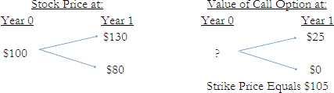

Figure 1: Stock and Option Call Values at End of Year 1

Alternatively, investors can synthetically create a payoff pattern of the same magnitude (i.e., in one year's time, receive a multiple of either $25 or $0 with equal probability) by borrowing the present value of the lower ending stock price. To see that this is true, examine the pay-off patterns illustrated below:
1 The purchaser of a call option has the right, but not the obligation, to purchase the risky asset from the seller of
this option at the exercise price. The purchaser of a put option has the right, but not the obligation, to sell the risky asset to the seller of this option at the exercise price. Conversely, the sellers of such options are obligated to perform (i.e., sell the asset if a call option or purchase if a put option) should the purchaser exercise the option.

Year 1 Stock Price
Year 0 Rise Fall

Buy Security:  Borrow Funds: |  | $100.00  $74.42 | Sell  Rep | Security:  ay Loan: | $130  $80 | $80  $80
Net | Investment: | $25.58 | Net | Proceeds: | $50 | $0

At the end of year one, the stock may either rise in value to $130 or fall to $80 with equal probability. If the former occurs, the investor will receive $50 after having paid an $80 loan (of which, $74.42 is principal and $3.81 is accrued interest at 7.5% per annum) from the proceeds of the stock sale. If the latter occurs, the investor's sale proceeds are exactly equal to the loan payoff amount. Because the investor borrowed funds (equal to the present value of the lower stock price), the net investment at acquisition was only $25.58. For this amount, the investor receives a pay-off pattern that is equal to exactly twice that expected by the option purchaser. This is illustrated (using the same method as before) in Figure 2.

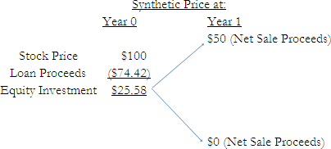

Figure 2: Pay-off Pattern on Synthetic Option

Accordingly, if two call options are worth $25.58, then one call option must be worth (approx- imately) $12.79. At any other price, option purchasers (or sellers) could synthetically create their own option (by combining the risky and risk-free assets) and arbitrage the mispriced option against the synthetic option. To understand this, note that an investor who owns the stock could sell two such call options, thereby creating a perfectly hedged portfolio that earns the risk-free rate of return. Examine the pay-off patterns under either stock price movement:

Year 1 Stock Price
Year 0 Rise Fall

Buy Security:  Sell Two Call Options: |  | $100.00  $74.42 | Sto  Optio | ck Value:  n Obligation: | $130  $50 | $80  $0
Net | Investment: | $25.58 | Net | Proceeds: | $80 | $80

Notice that, no matter the stock price investment, the investor will receive $80.00 for which the initial investment was $74.42. The rate of return on this investment is equal to the risk-free rate, assumed to be 7.5%.

  - Option Pricing and Real Estate’s Securitization. Notice that the crux of option pricing revolves around the risk-free arbitrage argument. Much of option (and futures) pricing is based on the ability to: 1) synthetically mimic the risky portfolio, and 2) arbitrage away any risk-less opportunities with the simultaneous sale and purchase of like-kind assets. That is, options are priced so that, no matter the direction (up or down) taken by the asset, the investor in the arbitraged investment will earn the risk-free rate of return. Heretofore, the notion that real estate investors (equity investors in particular) could create the type of arbitraged investment necessary to employ the option pricing model was more a matter of academic convenience than a practical reality. That is, the synthetic construction of investments needed to create risk-free arbitrage opportunities was virtually impossible and, accordingly, the option pricing model represented an insightful theoretical construct. However, with the tremendous growth in securitized real estate investments², institutional real estate investors will soon be offered a plethora of options- (and hedging-)based opportunities where the underlying asset is real estate.
While the real estate securities market, in its traditional form, offered little opportunity for such trading, there are indications that the institutional market is taking steps in this direction. Consider several recent market-based transactions: 1) a swap of returns from a corporate pension fund's equity real estate for floating-rate notes provided by an investment bank, see Williams (1993a);
2) a corporate pension fund's exchange of seven shopping centers for cash and stock from a real estate investment trust, see Williams (1993b); and 3) a public pension plan reduces its exposure 2 In 1993, approximately $8.6 million was raised in 43 initial public REIT offerings; through the first 9 months of
1994, approximately $7.0 billion has been raised in 23 offerings. See Vincour (1994).

to net-lease transactions by selling the leases on 59 properties to a real estate investment trust for cash and a convertible note, see Williams (1993c). Moreover, investors need not to confine their option (and hedging) programs to securitized real estate investments. The existence of real estate securities which have similar risk/return characteristics to unsecuritized real estate investments (e.g., an equity REIT which has its primary asset base apartments located in the southwest might be a decent proxy for the systematic risk of an unsecuritized apartment investment in Phoenix-the unsystematic risk will have to be diversified away) will enable real estate investors to replicate the movements of the unsecuritized transactions and, as a result, enable such investors to synthetically create the necessary risk-free arbitrage opportunities necessary to employ the option pricing model. Consequently, we view the maturation of the equity REIT market as not only providing real estate operators with access to the public capital markets but also generating, as a by-product of the former, an opportunity set of options-based transactions and pricing for real estate investors
which was previously impractical.

- OPTION PRICING: SINGLE PERIOD MODEL

This section will review the interplay of debt and equity components against the backdrop of the (unleveraged) asset's risk/return characteristics, where the time frame is a single period.

  - Asset's Risk/Return Characteristics. The value of any debt or equity investment can only be assessed in light of the (unleveraged) asset's risk/return characteristics. Moreover, in a world without income taxes (as can be found in a variety of institutional investors³ and qualified REITs⁴), it has long been asserted-see Modigliani and Miller (1958)-that the value of the asset is independent of its capital (debt and equity) structure.
Therefore, let us begin with a slight variation of the asset described previously. Assume that there exists a building (or a portfolio of buildings) with an initial value of $100. Let us further

3 As would be true for tax-exempt institutional investors such as pension, endowment and Taft-Hartly funds.
4 REITs must satisfy on-going requirements of the Internal Revenue Service in order to maintain their tax-exempt status, see

assume that it has the expected return⁵ (µ) of 12% with a standard deviation (o) of 20%, as illustrated in Figure 3.

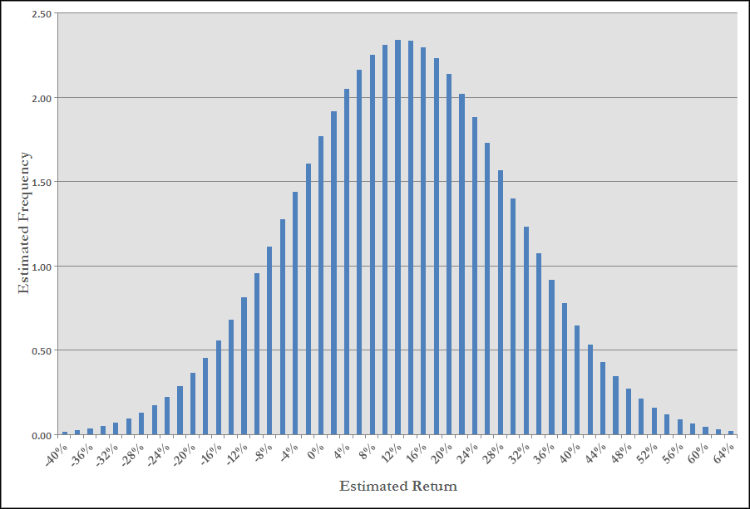

Figure 3: Asset's Expected Risk/Return Characteristics

Alternatively, the asset's risk/return characteristics can be described using a binomial model.
Generally speaking, the binomial model can be described as in Figure 4.

Where S_{O} represents the beginning asset value, S_{u} represents the "up" value, S_{d} represents the "down" value, and p represents the probability of S moving to S_{u} over the time period (t).

5 This represents the continuously compounded return (e^{µt}). It is used as a matter of mathematical convenience- to its counterpart the periodically compounded return [(1 + µ)t - 1]. The conversion from one rate of return to the other is quite simple: µ = ln(1 + µ). However, as a practical matter, unsecuritized real estate assets do not typically trade in a continuous time market (as do most stocks and bonds) and, therefore, the use of periodic (say, quarterly) compounding may be more appropriate.

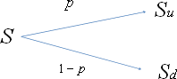

Figure 4: Generalized Binomial Model

The asset's "up" and "down" values, as well as their associated probabilities, can be determined from the following equations:

u = e t (1)

d = 1 = e⁻ t (2)
u

eµt d
-
p =
u - d

(3)

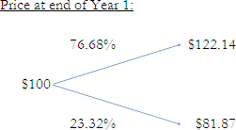
Using Equations (1) through (3) and the assumed risk/return characteristics of the asset results in the binomial model shown in Figure 5, which shows an up value of 122.14, with a probability of approximately 76.68%, and a down value of $81.87, with a probability of approximately 23.32%.

Figure 5: Illustrative Binomial Model

Using a continuous time model, these values approximate the mean and standard deviation of the assumed risk/return characteristics of the asset.⁶ Using the more practitioner-oriented discrete- time model, the asset's mean return is shown below:
6 Using the continuous time model, the average (or, expected) return of the binomial tree shown in Figure 5 is:

E(R

Asset
) = pS_{u} + (1 - p)S_{d} 1 (4)
S_{O}
-

O 7668(122 14)+O 2332(81 87) 1OO
= - 1
= 1

Note that continuous compounding at .12 and annual compounding at .1275 both represent the same ending asset value over any time period. The standard deviation of the asset's expected return is shown below:

o(R

Asset
) = p[ Su - 1 - E(R

Asset
)]2 + (1 - p)[ Sd - 1 - E(R

Asset

)]2 (5)

= [ ¹²² ¹⁴ - 1 - 1 ]2 + [ ⁸¹ ⁸⁷ - 1 - 1 ]2 = 1
Whether one uses the continuous- or discrete-time model is largely unimportant. However, it is important to understand their implications and convertibility.
S_{O}
S_{O}
1OO
1OO
Though the binomial model is a gross oversimplification of the asset's expected behavior, it provides a better understanding of more complex and realistic models- which are addressed in subsequent sections of this paper. Additionally, this approach, enables us to more simply value the debt and equity pieces of this asset once it is levered.

x = ln(pu+(1-p)d)
= ln(0.7668(1.2214)+0.2332(0.8187)) = 0 12
t
1

and the standard deviation is
✓
o- = p(ln u - x)2 + (1 - p)(ln d - x)2
✓
= 0 7668(ln 1 2214 - 1 12)2 + 0 2332(ln 0 8187 - 0 12)2 � 0 17
The smaller the time interval, the closer the standard deviation of the binomial tree value will be to that of the asset. For example, if quarterly periods are used (i.e., t = .25), then the standard deviation increases to .194 (while the annualized mean (using continuous compounding) still equals 12).

  - Invoking the Risk Natural Argument: Mortgage Investments. Let’s further assume that a lender is willing to make a mortgage loan secured only by the property (or portfolios of properties).⁷ The origination of a mortgage loan⁸ creates an option for the borrower, whereby the borrower can "put" the property back to the mortgage lender should the property's future performance turn adverse.
That is, the lender will receive all of its principal and interest in the case that the property takes the "up" path and, conversely, will only receive the property value should the property take the "down" path. These values are portrayed in Figure 6.
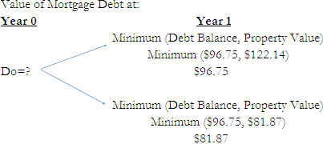
Figure 6: Generalized Debt Valuation

In a risk-neutral setting (i.e., where the lender has the opportunity to synthetically create a perfectly hedged portfolio), the lender prices this call premium so as to earn the risk-free rate of return.
Because the lender will receive the risk-free rate of return, it holds that the pseudo-probability (p) of a rise in the asset's value must result in a weighted return equal to the risk-free rate (r). This can also be written as:

1 + r = up + (1 - p)d (6)

7 This is a non-recourse mortgage. And, in the case of a portfolio of properties, the correlation of the income streams and asset values amongst the properties would have to be examined in addition to their mean return and standard deviation.
8 For ease of presentation, we will assume that this loan represents a zero-coupon loan with annual compounding and maturing in one year.

The terms of Equation (4) can be rearranged as to restate the pseudo probability (p)- see Equation (5) below:

p = 1 + r - d

(7)

u - d

Given the previous assumptions, the estimated pseudo probability equals (approximately) 63.64%. The value of the initial debt position (D_{O}), then, is simply computed by multiplying the expected pay offs under the up and down values times the appropriate pseudo probabilities and discounting this weighted value at the risk-free rate- as shown below:

D = pD_{u} + (1 - p)D_{d}

O
1 + r

(8)

O 6364(96 75)+O 3636(81 87) 1 O75
=
= $ 4 9

Notice that this option-adjusted price, $84.97, is $5.03 less than the face value of the initial loan amount. This difference represents the risk-neutral default premium to be paid to the lender (at the loan's origination) by the buyer to fairly induce the lender into accepting the possibility that the asset value (S_{d}) may decline beneath the loan's (principal and interest) balance. Given this default premium, the lender's expected return [E(R)] is shown below (note: here the pseudo probabilities are ignored):

E(R

Loan
) = pD_{u} + (1 - p)D_{d} 1 (9)
D_{O}
-

O 7668(96 75)+O 2332(81 87) 84 97
= - 1
= 9

The standard deviation of the expected return is shown below:

o(R
= [ ⁹⁶ ⁷⁵ - 1 - 9 ]2 + [ ⁸¹ ⁸⁷ - 1 - 9 ]2

Loan
) = p[ Du - 1 - E(R

Loan
)]2 + (1 - p)[ Dd - 1 - E(R

Loan

)]2 (10)

84 97
D_{O}
D_{O}

= 4
84 97

Notice that the lender's expected return (.0978) is smaller than the asset's expected return (.12) and that standard deviation of the lender's return (.0741) is substantially smaller than the asset's (.20). Using these characteristics, the distribution of the mortgage loan's expected return can be graphically illustrated-as was done in Figure 3 with the asset's expected return. There is one notable difference: the contractual nature of the lender's investment limits the loan's total return to $96.75- no matter how high the "up" path takes the asset value- for a maximum return of 13.864%. Thus, the lender's return distribution is truncated at this limit, as shown in Figure 7.
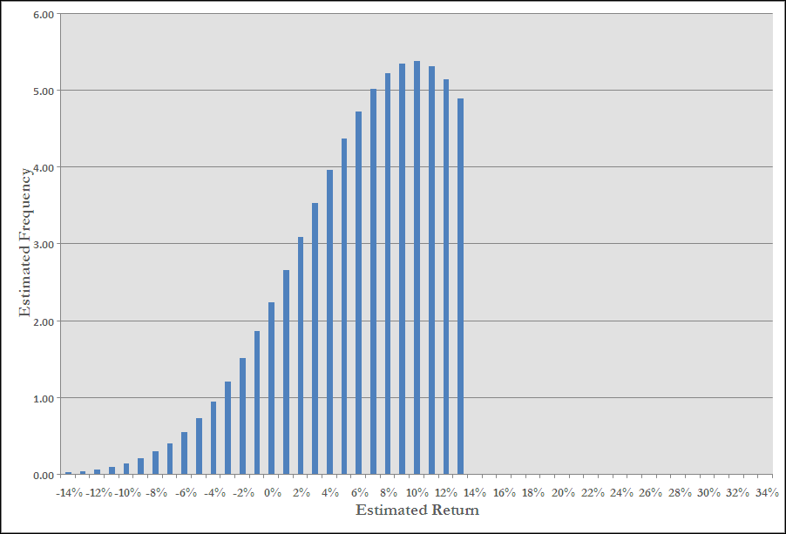

Figure 7: Debt's Expected Risk/Return Characteristics

As Figure 7 illustrates, the typical notion of standard deviation conveys a less-than-perfect depiction of the loan's asymmetric risk profile. That is, lenders face an unlimited down side (i.e., the potential of losing their entire investment) yet their up side is contractually limited.
  - Invoking the Risk Neutral Argument: Equity Investments. The equity side of the investment essentially represents the mirror image of the lender's side. While the asset's character- istics remain unchanged, the asset's risk/return characteristics are merely reapportioned amongst lender and borrower.
To continue with our earlier example, the equity investor faces the other side of the put option. The investor retains the equity in the project should the asset value rise above the loan balance and abandons the project should the asset value fall below the loan balance. These values are portrayed in Figure 8.
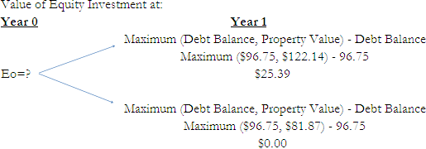

Figure 8: Generalized Equity Valuation

Using the same pseudo probabilities as calculated for the lender (see Equation 5), the option- adjusted pricing of the initial equity position (E_{O}) can be determined as follows:

E = pE_{u} + (1 - p)E_{d}

O
1 + r

(11)

O 6364(25 39)+O 3636(O) 1 O75
=
= $1

This value of the equity component can be viewed from several different perspectives. First, given an asset price of $100.00 and option-adjusted loan proceeds of $84.97, the equity price must

equal the difference, $15.03- that the option-adjusted equity requirement is identical to this amount is no mere coincidence. Second, that the sum of the debt and equity components equals the value of the asset is entirely consistent with the capital-structure irrelevancy argument of Miller and Modigliani (1958). These components derive their values from the asset's risk/return characteristics and not the other way around. Third, the equity investor can be viewed as funding the initial equity requirement (i.e., the asset's initial value less the face amount of the loan- or, $10.00) plus the lender's required default premium (i.e., the face amount of the loan less the option-adjusted price- or, $5.03). In any event, the relationships between the asset's value (and its risk/return characteristics) and the option-adjusted pricing of the debt and equity components is consistent all with all three points of view.
Given the preceding, the borrower's (or investor's) expected return is shown below (again note: the pseudo probabilities are ignored):

E(R

u t
) = pE_{u} + (1 - p)E_{d} 1 (12)
E_{O}
-

O 7668(25 39)+O 2332(O) 15 O3
= - 1
= 9

The standard deviation of the expected return is also shown below:

o(R
= [ ²⁵ ³⁹ - 1 - 9 ]2 + [ ^{O} - 1 - 9 ]2

u t
) = p[ Eu - 1 - E(R

u t
)]2 + (1 - p)[ Ed - 1 - E(R

u t

)]2 (13)

15 O3
E_{O}
E_{O}

= 14
15 O3

Notice that the equity investor's expected return (.2953) is substantially higher than the as- set's expected return (.12) and that the standard deviation of the equity investor's expected return (.7143) is also substantially higher than the asset's (.20). Using these characteristics, the distribu- tion of the equity investment's expected return can be graphically illustrated. As with the mortgage loan's expected return, the distribution of the equity investment's return is asymmetric. However,

this time the difference lies on the "down" side. Because of the non-recourse nature of the assumed loan, the borrower can lose no more than 100% of its of its initial investment ($15.03)- no matter how low the "down" path takes the asset value. Therefore, the borrower's return distribution is truncated at this limit, as shown in Figure 9.
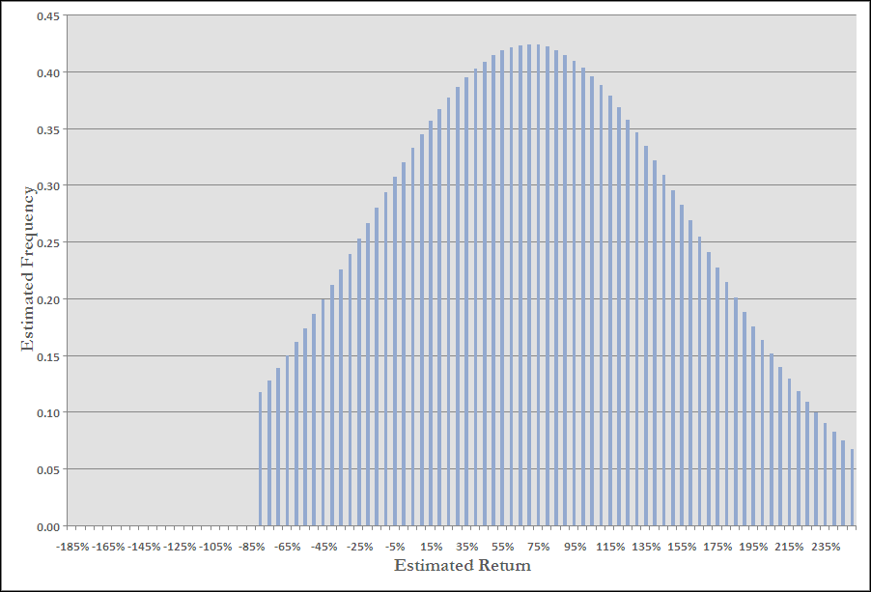

Figure 9: Equity's Risk/Return Characteristics

Again note that the typical notion of standard deviation conveys a less-than-perfect depiction of the equity investment's asymmetric risk profile. That is, borrowers face an unlimited up side, yet their down side is contractually limited to their initial investment.

  - The Role of Leverage and Risk/Return Characteristics. The preceding examples also illustrate the role leverage plays in the risk/return characteristics of the debt and equity com- ponents. As noted here and elsewhere, leverage simply serves to reapportion the asset's risk/return

characteristics between the lender and the borrower. This reapportionment is magnified as the leverage ratio increases.
To quickly see that this is the case for the return characteristics, let us recall the Miller and Modigliani (1958) proposition⁹ on leveraged equity returns:

E(R

u t
) = E(R_{Asset}) - E(R _{e t}) e er e
1 - e er e

(14)

Using Equation (14) and presenting the results of the preceding examples in tabular form, the role of leverage on the return characteristics can be seen below:

Component | Capitalization Weighting | Expected Return/<Cost> | Weighted Return/<Cost>
Asset | 100.00% | 0.1275 | 0.1275
Debt | 84.97% | <0.0978> | <0.0831>
Equity | 15.03% | 0.2954 | 0.0444

As the table above shows, we have used the M&M proposition to independently generate an expected equity return of 29.54%-the same as that determined by using the option-based approach. More generally, given the expected return of any two components (and the leverage ratio), the expected return of third component can be identified.
Interestingly, the same approach can be applied to the risk characteristic. Equation (14) can be recast in terms of the standard deviation, as follows:

o(R

u t
) = o(R_{Asset}) - o(R _{e t}) e er e
1 - e er e

(15)

Using Equation (15) and again presenting the results of the preceding examples in tabular form, the role of leverage on the risk characteristics can be seen below:

9 See Miller and Modigliani (1958) pp. ; their notation has been modified to conform with notation used in this article.

Component | Capitalization Weighting | Standard Deviation | Weighted Standard Deviation
Asset | 100.00% | 0.1703 | 0.1703
Debt | 84.97% | 0.0741 | 0.0630
Equity | 15.03% | 0.7143 | 0.1074

As the table shows, we have used a variation of the M&M proposition to independently generate the standard deviation of the expected equity return of 71.43%-the same as that determined by using the option-based approach. As with expected returns, given the standard deviation of any two components (and the leverage ratio), the standard deviation of a third component can be identified.
Obviously, the preceding examples are sensitive to the degree of leverage. The following sections will explore the impact of a changing leverage ratio; but before we do, let's first consider the case of hybrid debt/equity investment- the participating mortgage.
  - Invoking the Risk Neutral Arguments: Participating Mortgages. As one type of hybrid debt/equity investment, let us examine the participating mortgage.¹⁰ Let us amend our earlier examples to incorporate a mortgage feature that provides the lender with a participation in the asset's appreciation (in excess of the mortgage loan balance). For ease of analysis, let us assume that the participation percentage (,X) equals 40%. In this case, the lender's pay-off pattern is as shown in Figure 10.

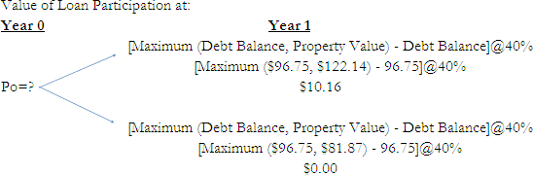

Figure 10: Generalized Loan Participation Valuation

10 Other potential hybrid investments include convertible mortgages and certain joint venture arrangements. Though
these investment vehicles are similar to participating mortgages, important differences can exist. Accordingly, caution should be taken in extrapolating the analysis of participating mortgages to other hybrid investment vehicles.

Notice that the lender's participation in the asset's appreciation is identical to that of the equity investor. Essentially, if the asset rises in value (above the debt balance), the participating lender shares in the net appreciation and, conversely, if the asset falls in value (below the debt balance), the lender's participation is worthless. The value of the initial participation position ( _{O}) is calculated, with the same pseudo probabilities, as before:

p = p _{u} + (1 - p) _{d}

1 + r
O 6364(1O 16)+O 3636(O) 1 O75
=
= $ 1

(16)

Thus, the option-adjusted pricing of the participation feature equals exactly 40% of the option- adjusted pricing of the equity investment as calculated earlier. This too should come as no surprise. First, note that the values shown in Figure 10 are equal to 40% of those shown in Figure 8 which valued the equity component assuming conventional (i.e., non-participating) mortgage debt. Math- ematically, the result is entirely to be expected. Second, note what the lender has really done is purchase 40% of the borrower's interest in the residual value of the property. Consequently, this purchase should take place on a ratable basis-and it did. Therefore, the risk/return characteris- tics of the borrower's investment remains unchanged, while the risk/return characteristics of the lender's investment now represent a weighted blend of the characteristics of the conventional debt combined with those of the participation feature.
Lastly, it should also be noted that the preceding analysis was based on the lender participating in appreciation above the loan balance. If this minimum were raised (e.g., to the asset's initial value of $100), then the value of this participation feature would decline- and not in a ratable way (like the participation percentage, ,X).
  - The Impact of Changing Leverage Ratios. In order to isolate the impact of leverage, the following sections will examine the range of leverage ratios from 0% to 130% of the initial price (S_{O}) in increments of 5%. Our goal is to provide an integrated perspective on the pricing and risk/return characteristics of debt and equity components as the leverage ratio changes.

Changing Default Premiums and Contracted Interest Rates. The default premium is the difference between the face amount of the loan and the option-based pricing of the loan. This difference represents the amount necessary to induce the lender to sell a put option to the borrower. The contract interest rate represents the lender's rate of return if the borrower repays the loan balance plus accrued interest-given the lender's initial investment (i.e., the face value of the loan less the default premium). Both the default premium and the contract interest rate, among other matters, are examined in Figure 11.

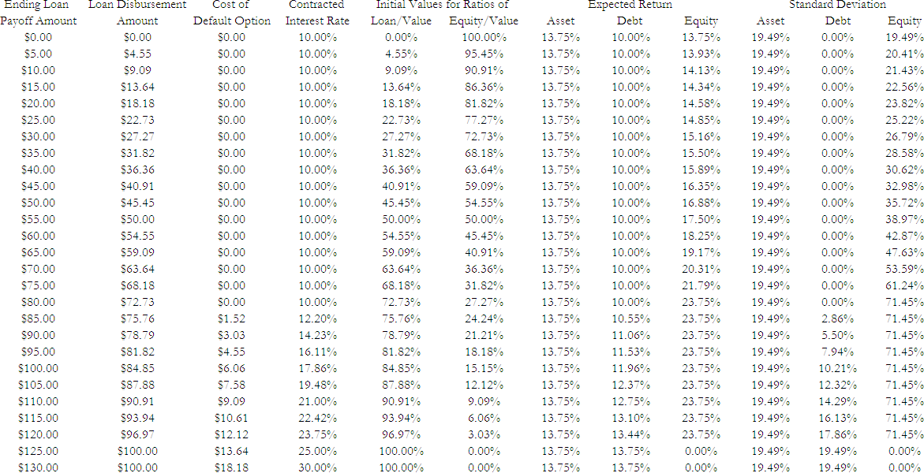

Figure 11: Sensitivity to Changes in Loan Amount

Figure 11 shows that any loan pay-off amount (i.e., the sum of principal and accrued interest) which is equal to or less the "down" value (S_{d}) bears no default (or, risk) premium. That is, the lender is assured of receiving the loan's principal and interest balance upon loan maturity and, accordingly, the lender's interest rate equals the risk-free rate. However, once the loan pay-off amount exceeds the "down" value, the lender then assumes some risk of only a partial repayment. In order to bear this risk, the lender charges a default premium¹¹ that can be measured as the 11 In practice, the lender can charge this premium in several ways: 1) loan origination and/or discount fees, 2)

difference between the face loan amount and the option-adjusted price of the debt component. Notice that once the loan pay-off amount exceeds the down value (of $81.87)-but before the up value (of $122.14) is reached-the default premium increases by approximately $1.82 for every $5.00 increase in the loan's face value. This $1.82 equates to the increase in the initial face amount of the loan ($5.00) times the pseudo probability (1 - p = ) of the down value occurring. In other words, the increase in the lender's default premium represents the pseudo probability-weighted cost of a downward movement in asset value(s). After the loan pay-off amount equals or exceeds the "up" value of the asset ($122.14), the increase in default premium is equal to the increase in the promised loan pay-off amount- in this example, $5.00. This $5.00 equates to the increase in the initial face amount of the loan ($5.00) times the 100% probability that the loan pay-off amount will exceed the up value. Notice that, no matter what the borrower promises to repay the lender upon loan maturity, the lender's option-adjusted pricing never permits more than the initial asset price ($100) to be lent. Moreover, at this disbursement level, the lender effectively becomes the equity investor in (unleveraged) asset- with the lender facing the same risk/return characteristics as the unleveraged equity investor.

Notice that, as the default premium increases, the lender's contracted interest rate also increases. This increase is due to the widening spread between the face value of the loan and the loan's option- based pricing (or alternatively, the cost of the default premium) and that accrued interest is earned on an ever-widening spread between the loan's face value and option-based pricing.
Figure 12 illustrates the relationship between the default premium and the contracted interest rate, as the face value of the loan increase.

Again, note that for loan pay-off amounts beneath the asset's down value, the lines representing the default premium and the contracted interest rate are flat. Once the down value is met, both lines show steady increases. Finally, as the loan pay-off amounts exceed the up value, both lines become even more steeply pitched.
increase in the stated interest rate, and/or 3) an explicit put option (written by the lender and) purchased by the borrower. The method by which the lender is compensated for bearing risk is less important than the determination of the appropriate compensation.

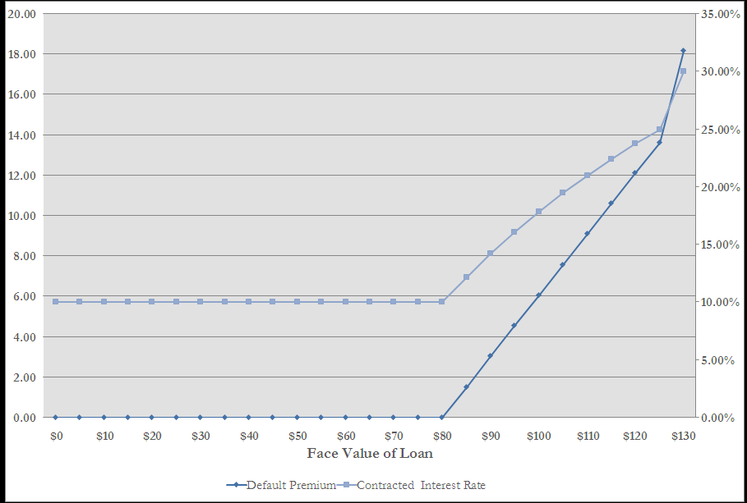

Figure 12: Estimated Default Premium and Contracted Interest Rate under Various Loan Amounts

Changing Contracted Interest Rates and Expected Return. The contracted interest rate should not be confused with the loan's expected return. Simply because the borrower promises to repay the loan (along with accrued interest) does not mean that it will (or, is likely to) happen upon loan maturity. The most vivid example of this disparity occurs when the loan's value exceeds the up value; in these cases, the borrower promises to repay the lender an amount which is in excess of the asset's up value. However, even using our earlier example of an initial loan value of $90.00, the disparity between the contracted interest rate (12.87%) and the loan's expected return (9.78%) is significant. Figure 13 summarizes the difference between the contracted interest rate and the loan's expected return.

Conceptually, the widening spread between the contracted interest rate and the loan's expected return simply represents a measure of the uncertainty of complete loan repayment (principal and accrued interest) as the loan amount increases. It is not coincidental that the path of the contracted

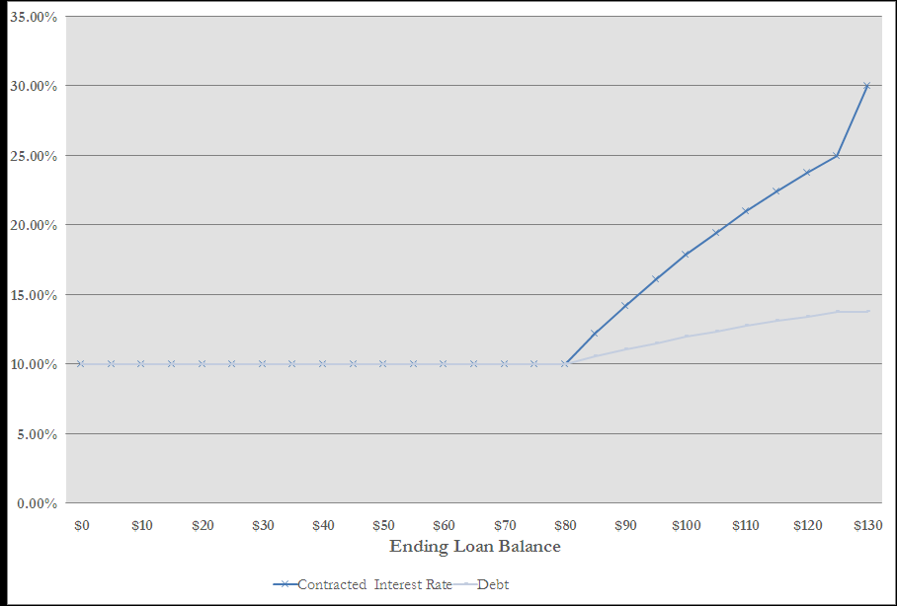

Figure 13: Estimated Contract Interest Rate and Expected Return as the Ending Loan Payoff Amount Increases

interest rate and the loan's expected return diverge once the loan pay-off amount exceeds the down value (S_{d} = $ ). Lenders must be compensated for the higher risk they assume at higher loan-to-value ratios. This compensation (for assuming the increasing likelihood of less than total loan repayment) is reflected in the higher contracted interest rate. Finally, also note that once the loan pay-off amount exceeds the up value (S_{u} = $1 14) then the loan's expected return converges to the asset's expected return (E(R_{Asset}) = 1 ).
The Risk/Return Interplay as Leverage Changes. This section will examine the inter- play of return (as measured by expected return) and risk (as measured by standard deviation) for the asset, debt and equity components as the leverage ratio changes.
Expected Return. As can be observed from the table presented in Figure 11, the asset's expected return is constant across all levels of leverage. Again, this is entirely consistent with the

Miller and Modigliani (1958) proposition regarding the irrelevancy of capital structure. However, the debt and equity components show different patterns- as also illustrated in Figure 14.
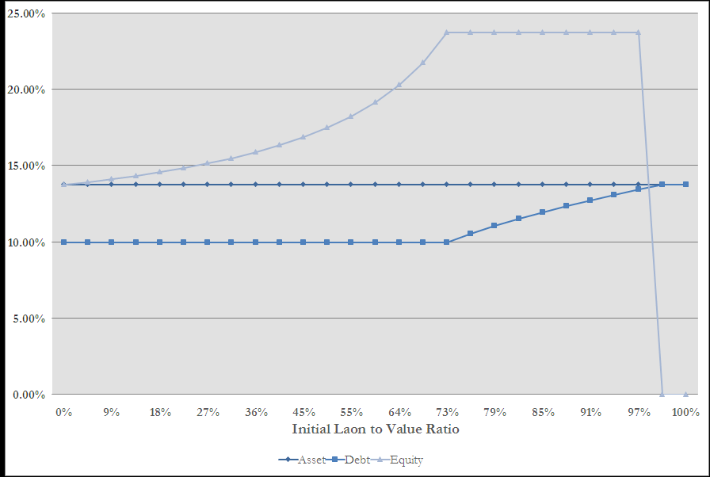

Figure 14: Expected Return Parameters as the Initial Loan to Value Ratio Changes

As can be seen in Figures 11 and 14, the loan's expected return is constant and equal to the risk-free rate so long as the loan's pay-off amount does not exceed the down value (S_{d} = $ 1 ). For the equity investor over this same degree of leverage (i.e., ::; loan pay-off amount ::; S_{d}), the expected return increases steadily until the down value is reached. This behavior in the expected return is entirely consistent with the M&M proposition (re: capital structure irrelevancy) and simply reflects that, while the lender is assured of a complete loan repayment (so long as the pay-off amount does not exceed S_{d}), the borrower is not similarly assured. The borrower faces the risk that asset's future value takes the downward path and that there will be insufficient proceeds to repay the investor's capital contribution (plus the risk-free rate of return).
Once the loan pay-off amount exceeds the down value (S_{d} = $ 1 )-but not the up value (S_{u} =

$1 14)-then the loan's expected return increases suffi ciently so that the lender is adequately compensated for the risk taken. Note that over this same leverage range (i.e., S_{d} < loan pay-off amount ::; S_{u}) the investor's expected return is capped at the return associated with financing the property so that the loan pay-off amount exactly equals the down value (in the present example, the maximum expected return is 29.52%).
Once the loan's pay-off amount exceeds the up value (S_{u} = $1 14), then the loan's expected return converges to the asset's expected return (12.75% in this example) and the loan proceeds are no more than the asset's initial value (S_{u} = $1 ). Thus, the equity investor (at least in an option-priced world) is "frozen out" of the asset (i.e. , the lender is unwilling to share the economic risks and rewards of the asset with the borrower when the borrower invests no capital).
Standard Deviation. As can observed from the table presented in Figure 11, the asset's standard deviation of return is also constant across all levels of leverage. Meanwhile, the debt and equity components show different paths- as also illustrated in Figure 15.

The similarities between Figures 14 and 15 are striking. Though the scale of Figure 15 is about twice the size of Figure 14, their patterns are virtually identical: the standard deviation of the loan's expected return is zero so long as the loan's pay-off amount does not exceed the down value (S_{d} = $ 1 ). Over this range the lender is assured of receiving the risk-free rate of return. For the equity investor over this same range (i.e., ::; loan pay-off amount ::; S_{d}), the standard deviation increases steadily until the down value is reached.
Once the loan pay-off amount exceeds the down value-but not the up value (S_{u} = $1 14)- then the loan's standard deviation steadily increases from zero until reaching the asset's standard deviation. The lender is compensated for this increase in risk via an increase in the expected return- see Figure 14. As with expected returns and over this same leverage range (i.e., S_{d} < loan pay-off amount ::; S_{u}), the investor's standard deviation of expected return is capped at the standard deviation associated with financing the property so that the loan pay-off amount exactly equals the down value (in present example, the maximum standard deviation is 71.43%).
Once the loan's pay-off amount exceeds the up value (S_{u} = $1 14), then the loan's standard deviation of expected returns converges to the asset's standard deviation. And, as before, because the investor is "frozen out" at this level of financing, the investor's standard deviation of expected

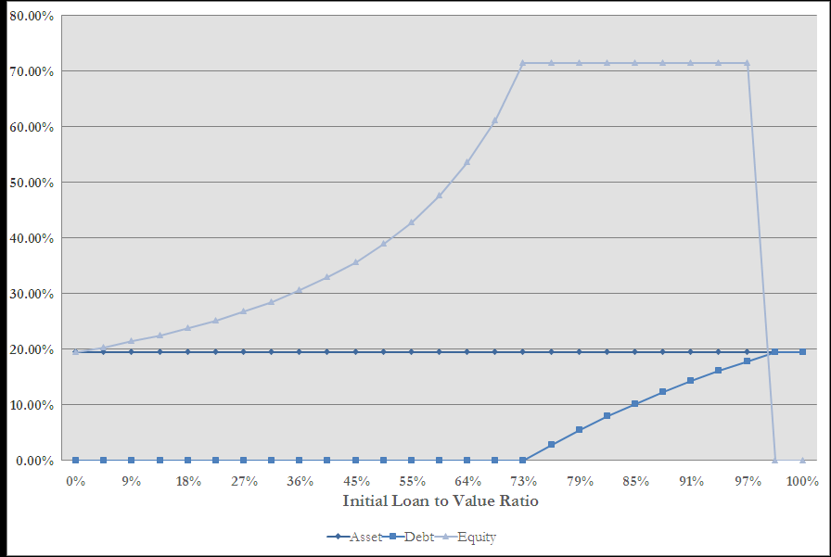

Figure 15: Risk (Standard Deviation) Parameters as the Initial Loan to Value Ratio Changes

return drops to zero.

  - Put Call Parity. As we have explored previously, the pricing of option-based securities rests on the ability to synthetically create a perfectly hedged portfolio (e.g., long the stock while selling call options on the same stock, short the stock while buying call option on the same stock, etc.) such that the risk-free rate of return (r) is earned. Consequently, it should come as no surprise that the value of put and call options (P and C, respectively) are inexorably linked to one another, in a relationship known as put-call parity, as follows:

C + X^{rt} = + S_{O} (17)
e

where xe-rt (using the continuous-time model) represents the present value of the option's exercise price-at the risk-free rate (f) over the expiration period (t). Thus, the value of the call

option (C) plus the present value of the exercise price (X_{e} - rt) must equal the value of the put option (P) plus the asset's initial value (S_{O})-for all instances where the put and call options have the same exercise price and expiration date.¹²
Miller (1988) recasts this put-call parity thereon in an interesting light:

S_{O} = C + xe^{-rt} - (18)
Equation (16) suggests that today's asset value (S_{O}) can be viewed as the sum of: 1) the call option (C) which represents the market value of the leveraged equity position, and 2) risk-adjusted value of the debt (X_{e} - rt - ) which represents the risk-free value of the asset's indebtedness (X_{e} - rt) less the risk-premium as measured by the put option (P) sold by the lender to the borrower. The value of the asset is unchanged by the leverage ratio-as we have seen in Figure 11-while the value of the debt and equity components can be greatly changed by the leverage ratio. In other words, the put-call parity is a reaffi rmation of the irrelevancy of capital structure with regard to asset value.
  - Concluding Thoughts on Single Period Option Pricing Model. As noted previously, the single-period binomial model represents a rather stilted view of the distribution of possible asset returns (and subsequent sections will relax this assumption). Nevertheless, the application of the single-period binomial option pricing model has led to several important insights:
    - Primacy of Asset Returns
By now, it should be abundantly clear that the asset's expected return distribution drives the valuation of the debt and equity components. Moreover, the weighted risk/return char- acteristics of the debt and equity components must sum to an unchanging set of risk/return characteristics for the asset, which is independent of the leverage ratio.
    - Option-Priced Debt Component
Using the option-based pricing model suggests the following for lenders: For loan pay-off amounts below or equal to the binomial model's down value (i.e.,x < S_{d}), the lender's
12 This also requires that the asset is non-dividend paying, that transaction costs and income taxes are zero, and
that the option is "European" (i.e., it cannot be exercised before its expiration date).

risk/return distribution mimics that of the risk-free security. For loan pay-off amounts greater than the down value but less than the up value (i.e., S_{d} < x < S_{u}), the lender's risk/return distribution converges towards those characteristics of the underlying asset. For loan pay-off amounts greater than or equal to the up value (i.e., S_{u} � x), the lender's risk/return characteristics becomes those of the asset's-as under the option-pricing framework, the lender would never permit a 100% leverage ratio. In all these cases, the lender can be viewed as selling the borrower a put option which will be exercised by the borrower should the asset value fall beneath the loan's pay-off amount. The sale of this premium reduces, when appropriate, the lender's advance to the borrower and increases the lender's expected return-suffi ciently to compensate the lender for bearing the risk of something less than complete loan repayment.
    - Option-Priced Equity Component
The symmetry of option-based pricing results in the equity investor taking the mirror image of the lender's position in the asset: For loan pay-off amounts less than or equal to the down value (i.e., x < S_{d}), the equity investor is exposed to increasing levels of risk and return- consistent with that modelled by Modigliani and Miller (1958). For loan pay-off amounts greater than the asset's down value but less than the up value (i.e., S_{d} < x < S_{u}), the equity investor's risk/return distribution is capped as if the investor had borrowed an amount such that the loan pay-off equals the down value. In other words, all additional risk borne by the lender for a loan pay-off amount greater than the asset's down value is offset by the lender completely absorbing the additional return which would have otherwise been available for the equity investor. For loan pay-off amounts equal to or greater than the up value (i.e., x � S_{u}) the equity investor is excluded from participating in the asset return.
    - Option-Priced Hybrid Debt
For those hybrid debts (such as participating loans) where the lender's participation threshold is set equal to the loan's pay-off amount, the lender has simply purchased a ratable piece of the equity investor's "action" and the option-based pricing is set accordingly. Where the lender's threshold is set higher than the loan pay-off amount, the value of the option-priced participation declines.

The following section analyzes more complicated, and more realistic, treatments of asset behav- ior. Yet, the principals noted above still hold true.
- OPTION PRICING: MULTI-PERIOD MODEL
Now, let's extend our earlier single-period example to a multi-period example. Conceptually, a four-period model is shown in Figure 16.

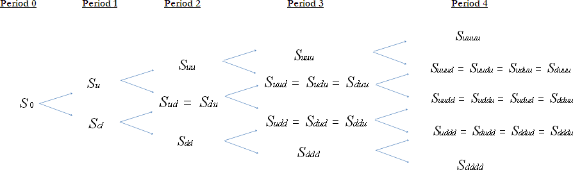

Figure 16: Generalized Multi-Period Binomial Model

This binary approach leads to what is known as a "recombining" tree. Notice that except for the extreme up and down values, more than one path leads to the interior asset values. For example, at the end of the second period the middle value can be reached either by: 1) an initial up movement followed by a down movement, or 2) an initial down movement followed by an up movement; such that: S_{ud} = S_{du}. By the end of the fourth period, the middle value can be reached by eight different paths.
Assuming the same asset parameters (with regard to annualized mean and standard deviation), let's use a four-period, quarterly example. Both examples provide estimated asset values at the end of one year. While the multi-period example generates a greater number of possible ending asset values, the risk/return characteristics are essentially unchanged.

As the trading interval during any given period becomes smaller, we will obtain results similar

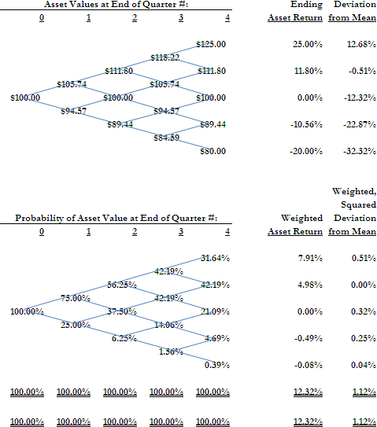

Figure 17: Illustrative Binomial Model- Quarterly Periods

to the closed-form solution of Black and Scholes (1973) and Merton (1973). The model can be easily extended to include a "jump process" or sudden change in value (see Page and Sanders (1985)).
The major drawback to either the single- or multi-period approach used in this paper is the underlying assumption that one can create a riskless hedge with real property. Since a piece real property is unique, there are only imperfect substitutes for it; moreover, the costs of private- market transactions make continuous rebalancing impractical. Several authors have developed "real" options, the Achilles heel of these approach is that they generally assume away the twin problems of imperfect substitutes and costly rebalancing.

REFERENCES
- Black, Fisher and Myron Scholes, "The Pricing of Options and Corporate Liabilities," Journal of the Political Economy, May/June 1973, pp. 637-659.
- Bodie, Zvi, Alex Kane and Alan J. Marcus, Essentials of Investment (Homewood, IL: Richard
D. Irwin, Inc. 1992).

- Brennan, J.J. and E. Schwartz, "Determinants of GNMA Mortgage Prices," AREUEA Journal, 1985, 13:2, pp. 209-228.
- Buser, Stephen A., Patric Hendershott and Anthony B. Sanders, "Pricing Life-of-loan Caps on Default-free Adjustable-rate Mortgages," AREUEA Journal, 1985 13:3, pp. 248-260.
- Buser, Stephen A., Patric Hendershott and Anthony B. Sanders, "On the Determinants of the Value of Call Options on Default-free Bonds," Journal of Business, 1990 63:1, pp. 33-50.
- Foster, C. and R. Van Order "FHA Terminations: Prelude to Rational Mortgage Pricing," AREUEA Journal, 1985 13:2, pp. 273-291.
- Hull, John C., Options, Futures and Other Derivative Securities, Second Edition (Englewood Cliffs, New Jersey: Prentice-Hall, Inc., 1993).
- Kritzman, Mark P., Asset Allocation for Institutional Portfolios (Homewood, IL: Richard D. Irwin, Inc., 1990).
- Miller, Merton H., "The Modigliani-Miller Propositions After Thirty Years," Journal of Eco- nomic Perspectives, Fall 1988, 2:4, pp. 99-120.
- Modigliani, Franco and Merton H. Miller, "The Cost of Capital, Corporation Finance and the Theory of Investment," American Economic Review, June 1958, 48:3, pp. 261-297.
- Nagaoka, Sanjay K. and Xiaoyang Zhuob, “Equivalent Expectations Measures for Risk And Return Analysis Of Contingent Claims, Journal Of Investment Management, Vol. 22, No. 3, (2024), pp. 23–36.
- Page, Frank and Anthony B. Sanders, "A General Derivation of the Jump Process Option Pricing Model," Journal of Financial and Quantitative Analysis, December 1988, 21:4, pp. 437-446.
- Shilton, Leon and James R. Webb, "Commercial Loan Underwriting and Option Valuation," Journal of Real Estate Research, 1989, 4:1, pp.1-12.

- Shilton, Leon and John Teall, "Option-Based Prediction of Commercial Mortgage Defaults," Journal of Real Estate Research, Spring 1994, pp. 219-236.
- Titman, Sheridan and W. Torous, "Valuing Commercial Mortgages: An Empirical Investiga- tion Contingent Claims Approach to Pricing Risky Debt," Journal of Finance, 1989, 44:2, pp. 345-372.
- Vandell, Kerry, "Predicting Commercial Mortgage Foreclosure Experience," Journal of the American Real Estate and Urban Economics Association, 1992, 20:1, pp. 55-87.
- Vincour, Barry, "A Host of Offerings Wait in the Wings to Test the Faltering Market for REITs,", Barrons, October 3, 1994, p.48.
- Williams, Terry, "AEW Uses Swaps in Realty Deal," Pensions and Investments, March 8, 1993, pp.2 and 31.
- Williams, Terry, "IBM Swaps Property for REIT Shares," Pensions and Investments, February 8, 1993, pp.1 and 39.
- Williams, Terry, "Ohio Sells Properties to REIT," Pensions and Investments, August 23, 1993, pp.1 and 33.

